**Namespaces in Header Files**

As an aside, you'll notice that the header files did not use the standard namespace. It's generally recommended to avoid using namespaces in a header file. This can help avoid naming conflicts later as functions and classes are reused in different parts of a code base.

# ifndef

The solution is to use # ifndef statements, which allow you to implement a technique called inclusion guards.

The ifndef statement stands for "if not defined". When you wrap your header files with #ifndef statements, the compiler will only include a header file if the file has not yet been defined. In the current main.cpp example, the "engine.h" file would be included first.

**#ifndef FILENAME_H**

**#define FILENAME_H**

header code ...

**#endif */* FILENAME_H */***

In order to storage a size_type variable:

std::vector<**int**>::size_type variablename;

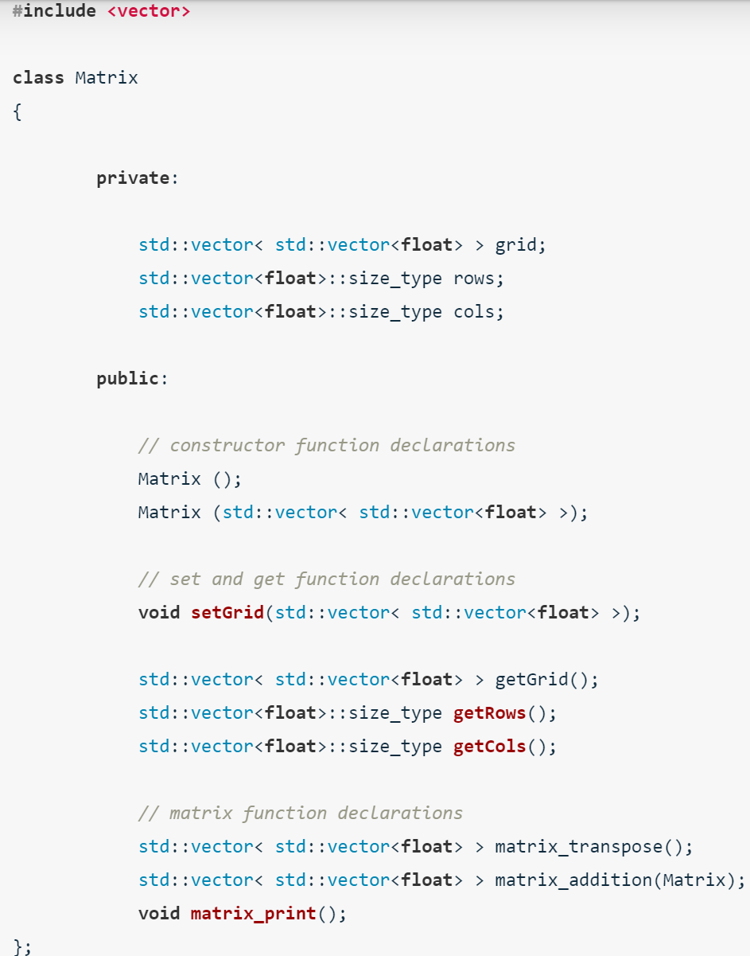

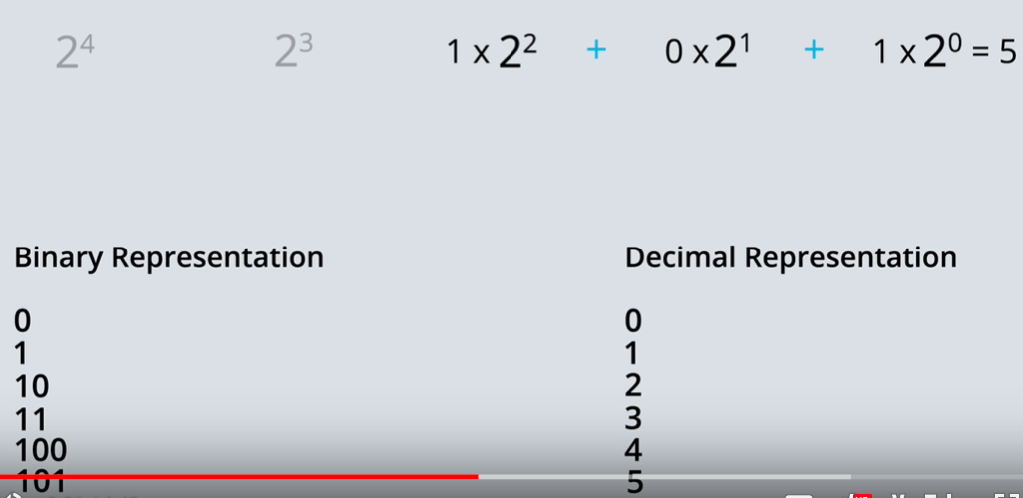

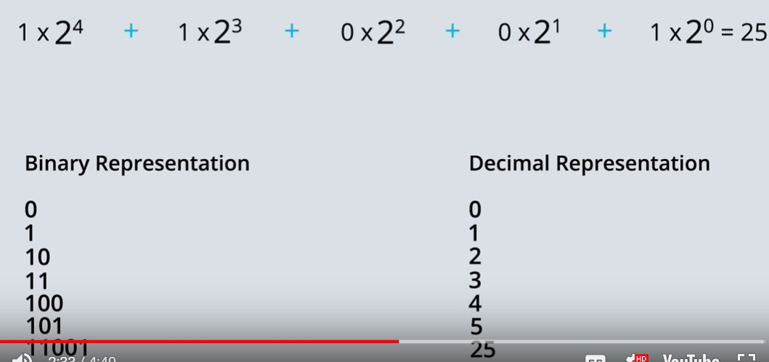

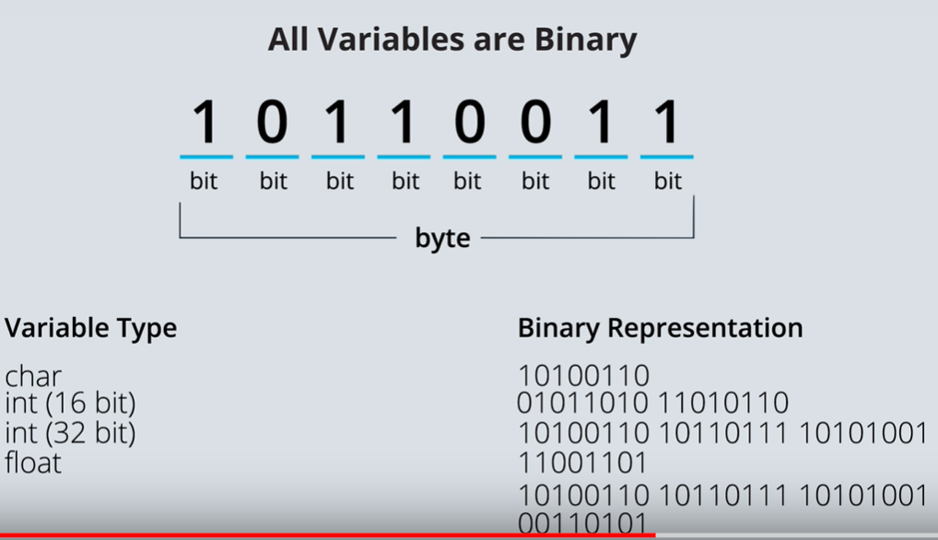

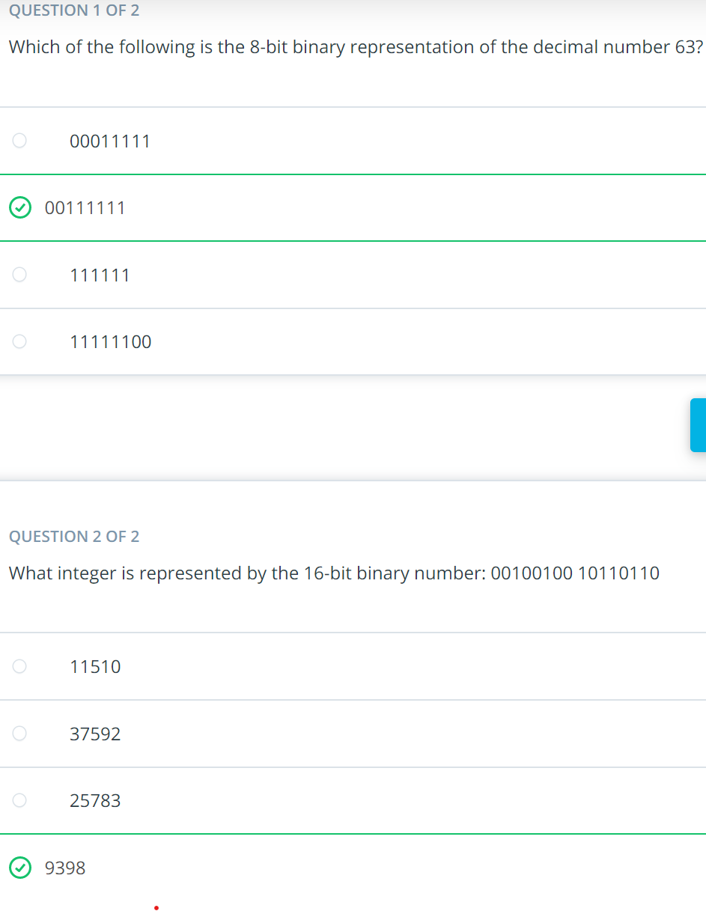

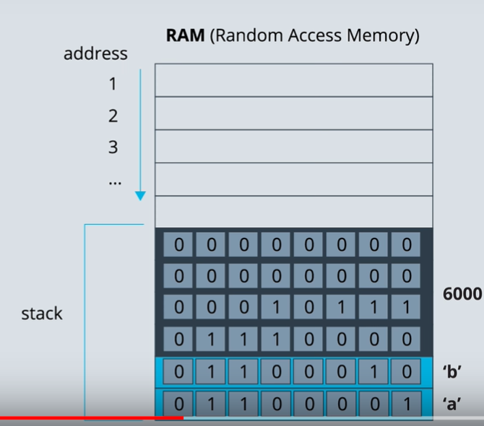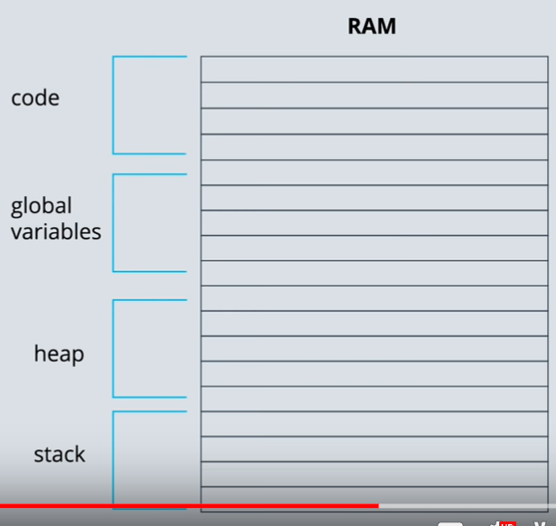



You could break down the code development process into the following steps:

* code design
* implementing the design
* testing for bugs and fixing the bugs
* optimization

If you were optimizing a large amount of code, you would want to use something called a profiler. A profiler is a piece of software that measures how long parts of your code are taking to execute or how many resources the code uses. The profiler helps you find congestion points so that you can optimize the least efficient parts of the code first.

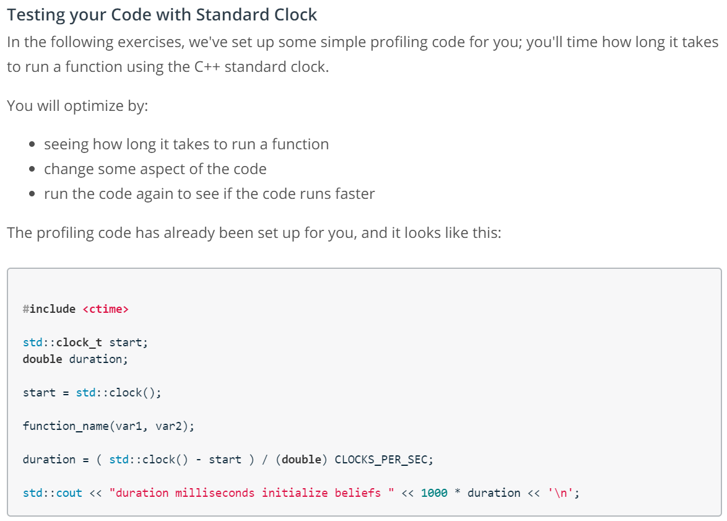

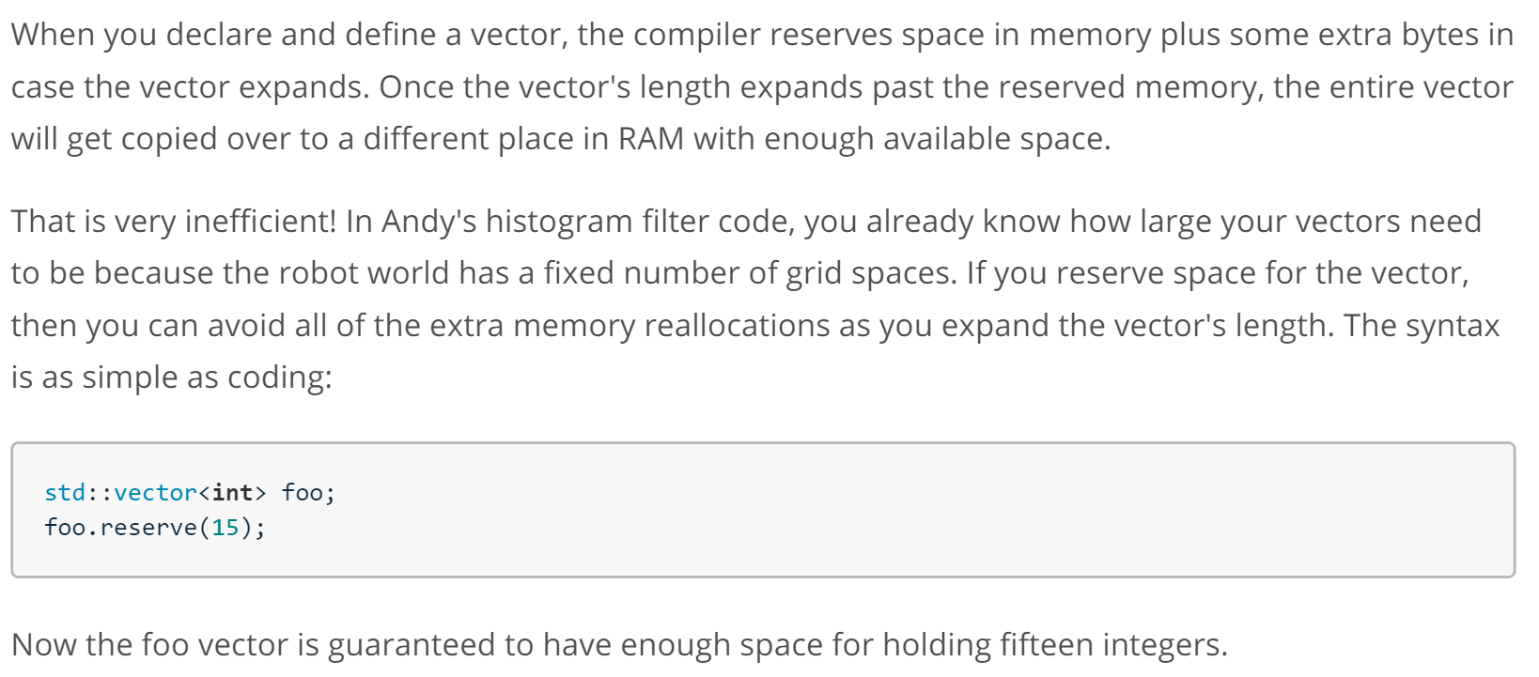

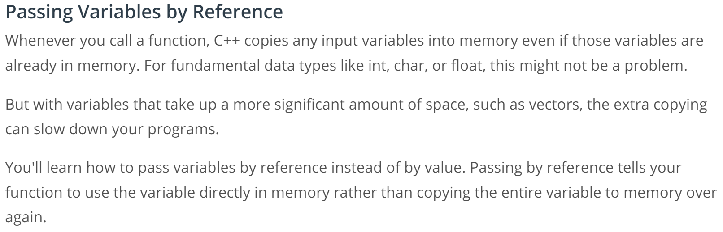

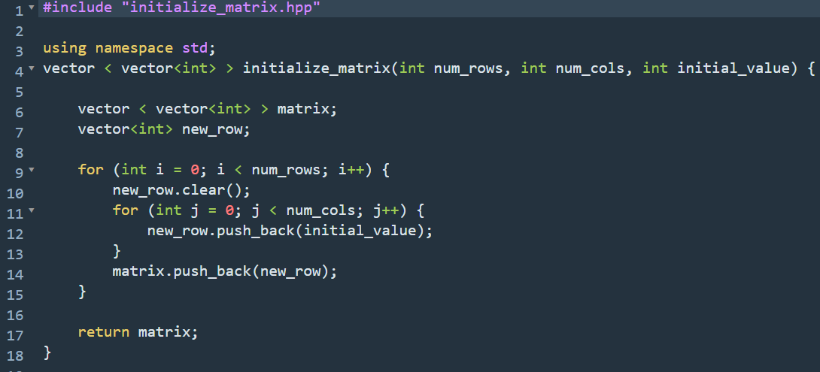

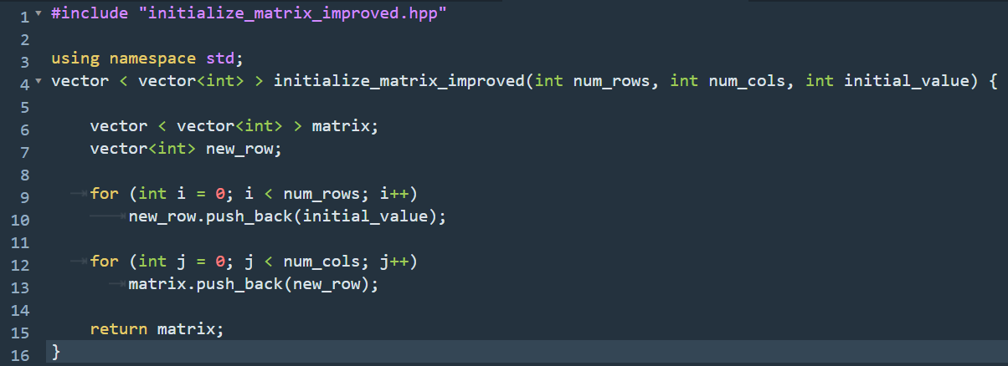

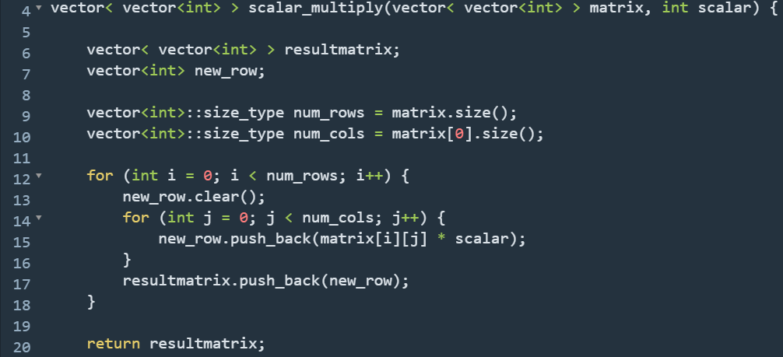

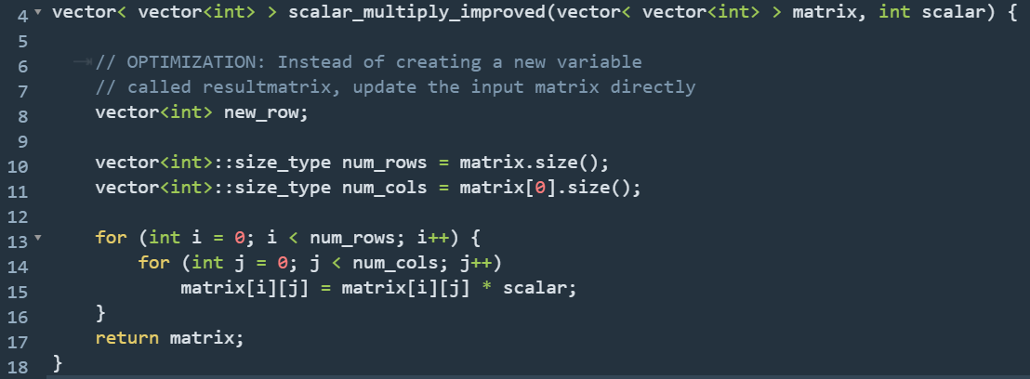

A vector is more efficient if you specify the vector's length before pushing values. You can do this with the reserve() method, which will guarantee that the vector can hold the number of elements reserved.

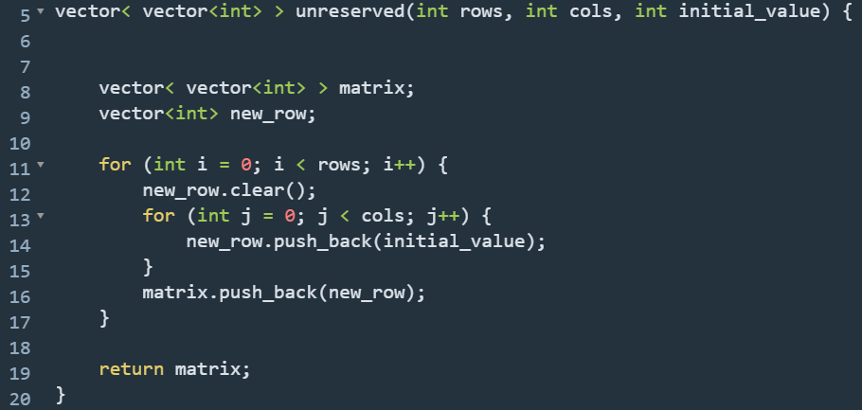

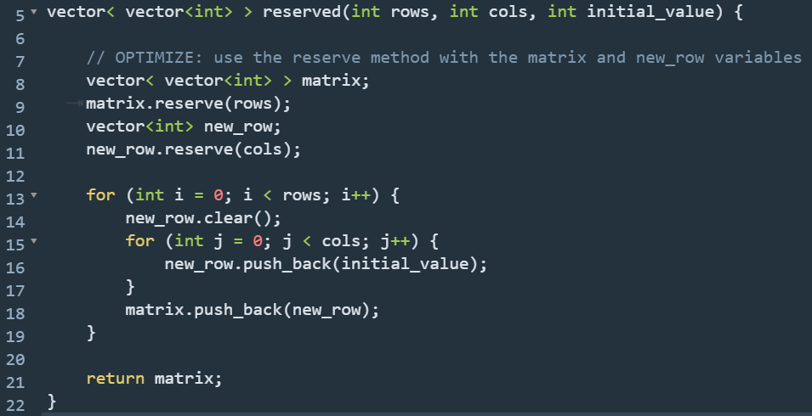

# References

Did you know that every time you call a function, those input variables get copied into memory?

The ampersand (&) tells the compiler to pass the input variable by reference. That means inside your function, you'll be working with the original variable instead of a copy.

# The Static Keyword

Sometimes you'll need to use the same variable over and over again in your functions.

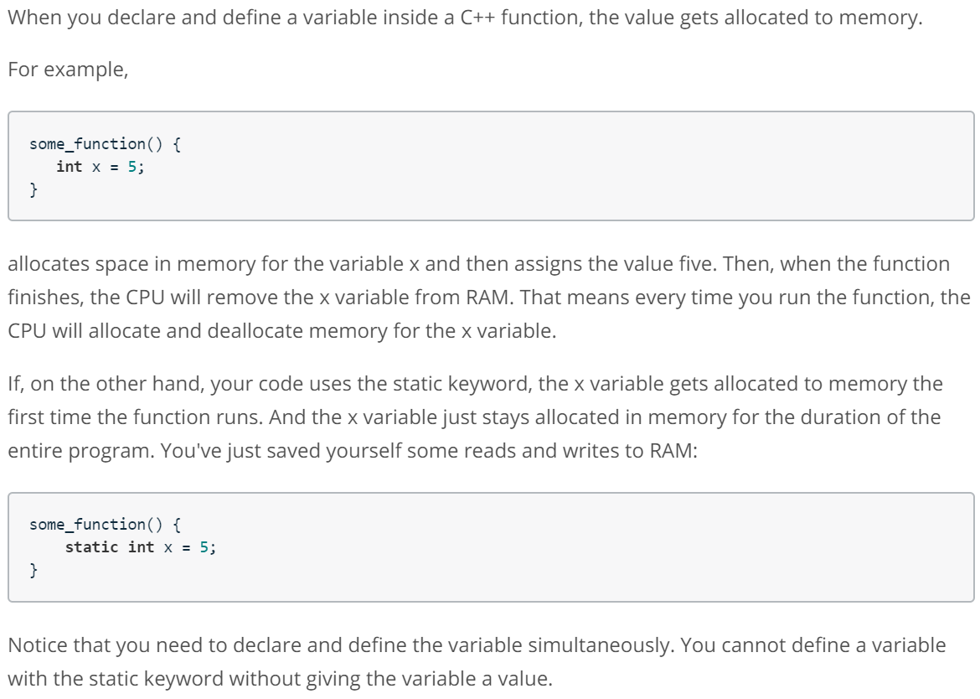

# Global Variables versus Static Variables

Static variables are actually placed in the same area of RAM as global variables. The difference is that global variables are declared outside of functions and are available anywhere in your program to any file or function. On the other hand, static variables remain in scope. So in the above example, some_function() is the only place that can access the x variable.

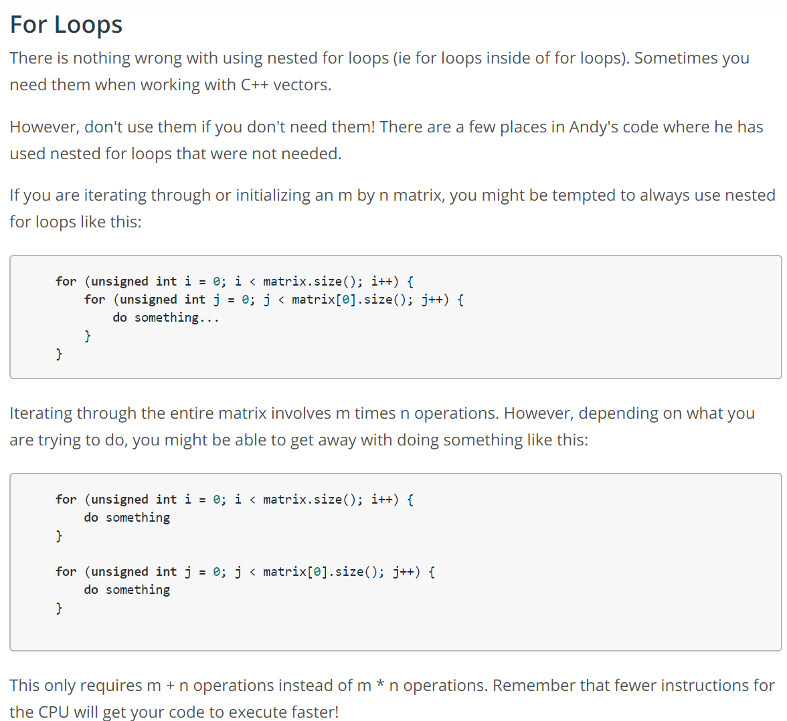

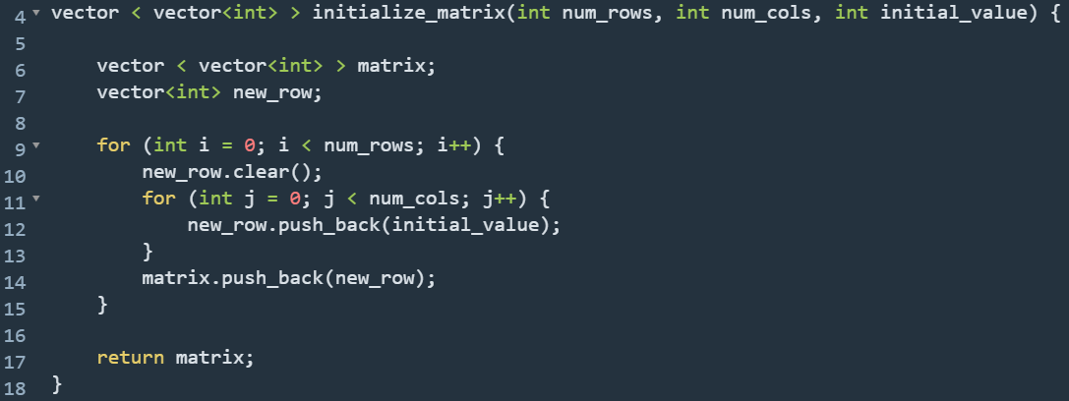

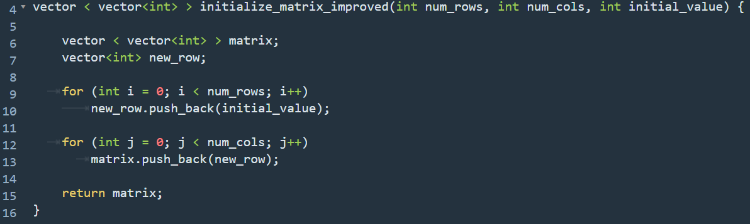

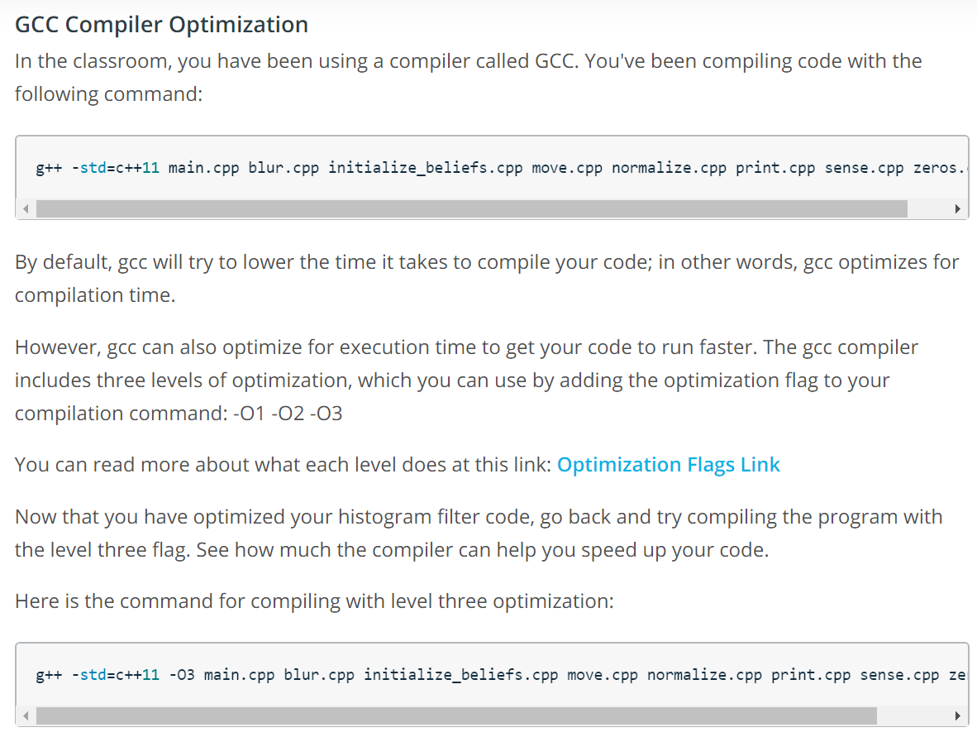

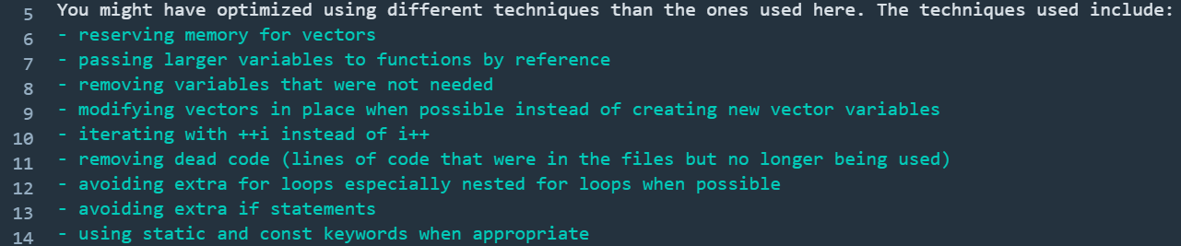

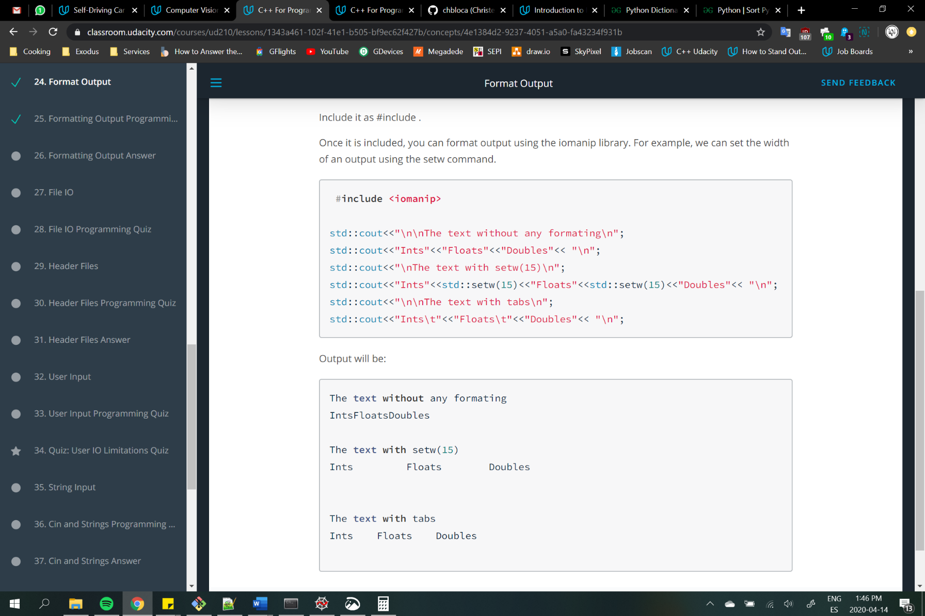

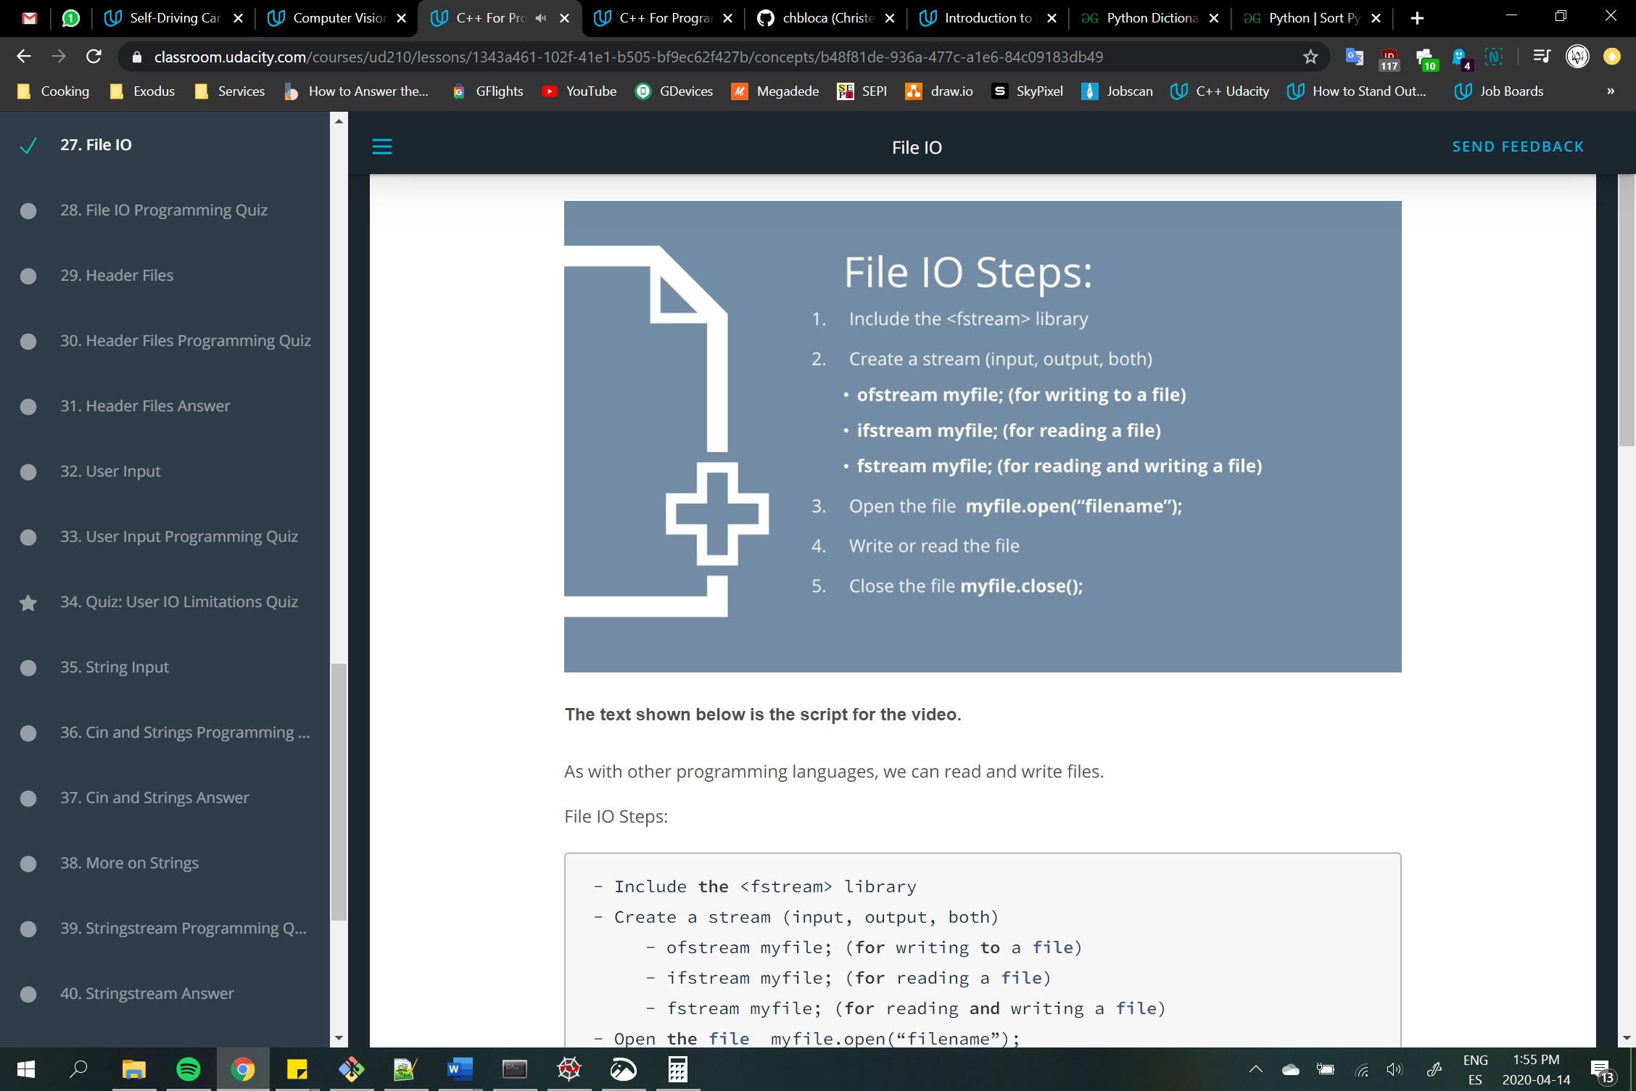

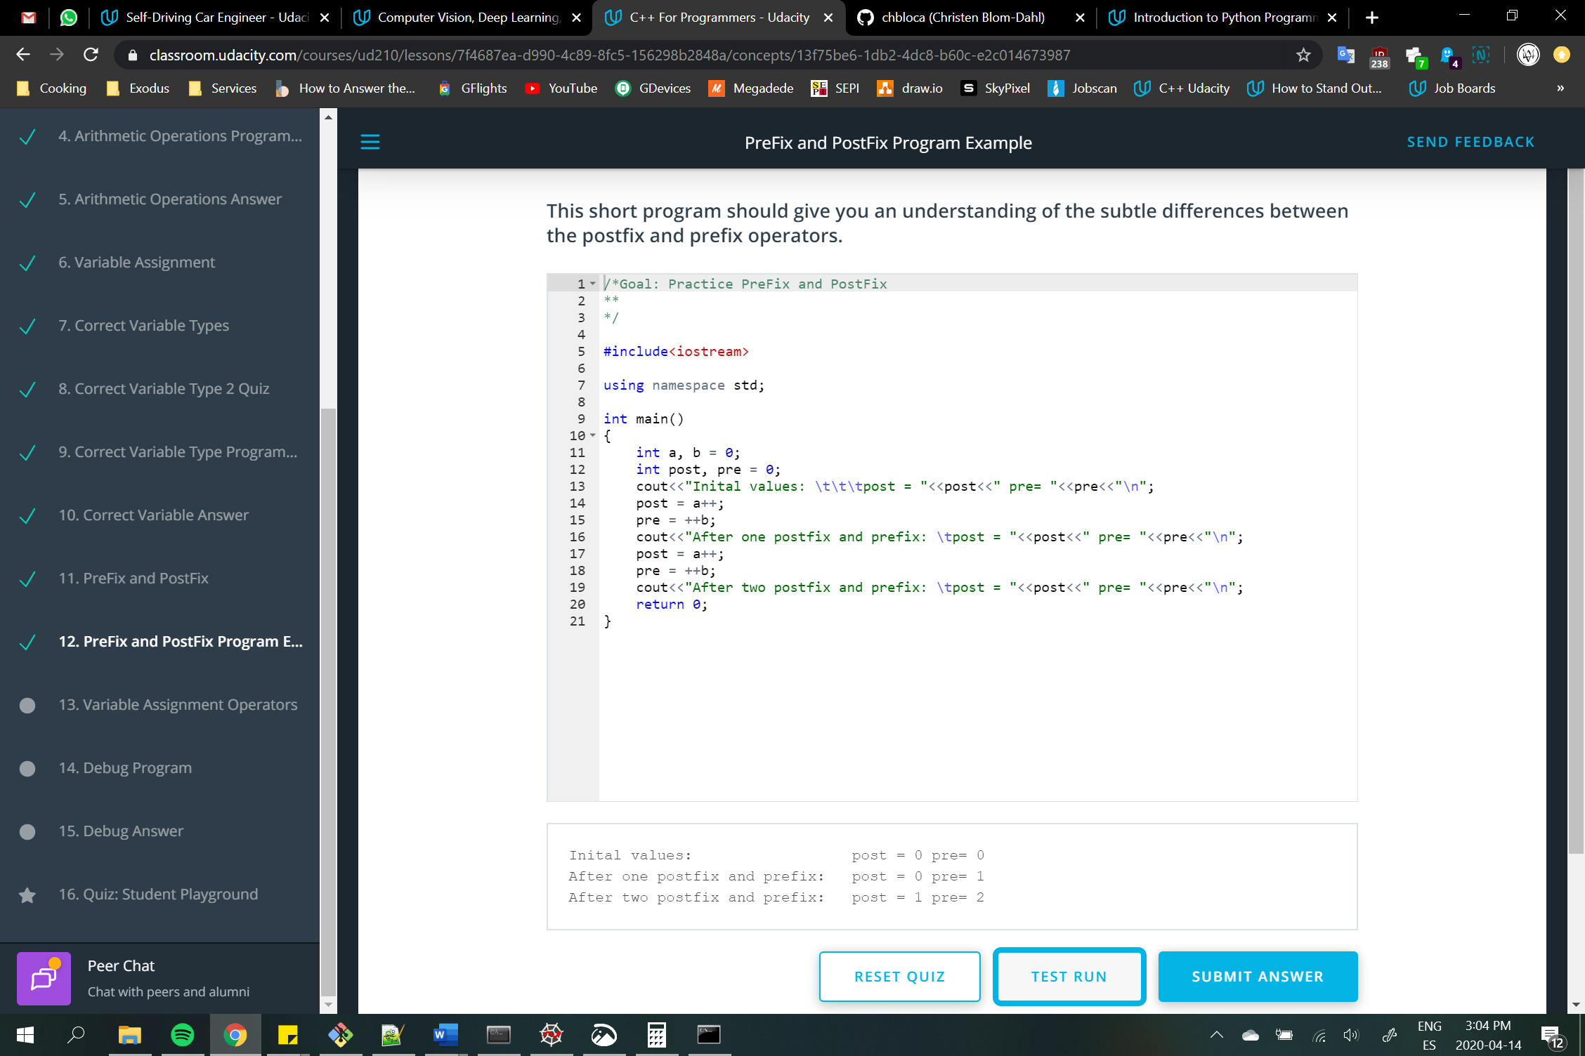

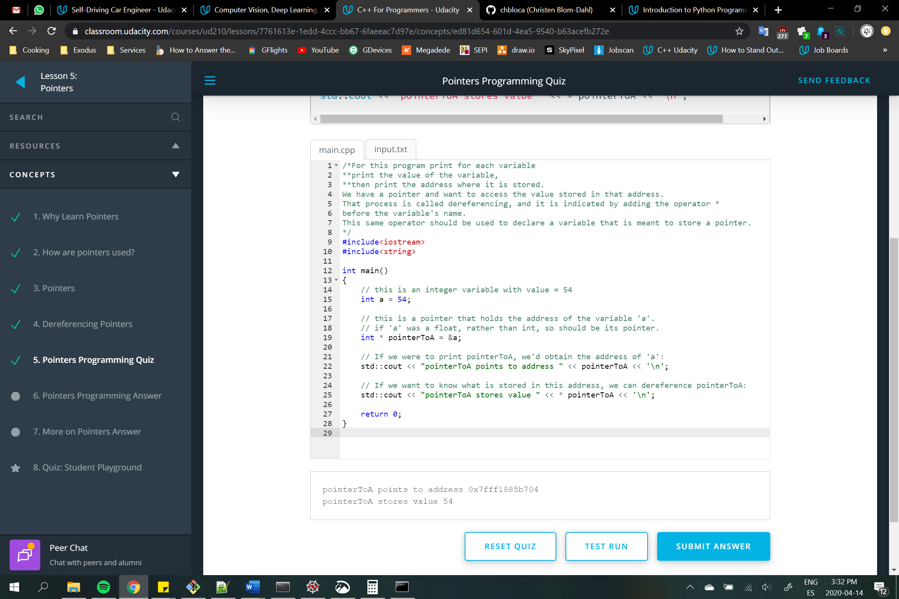

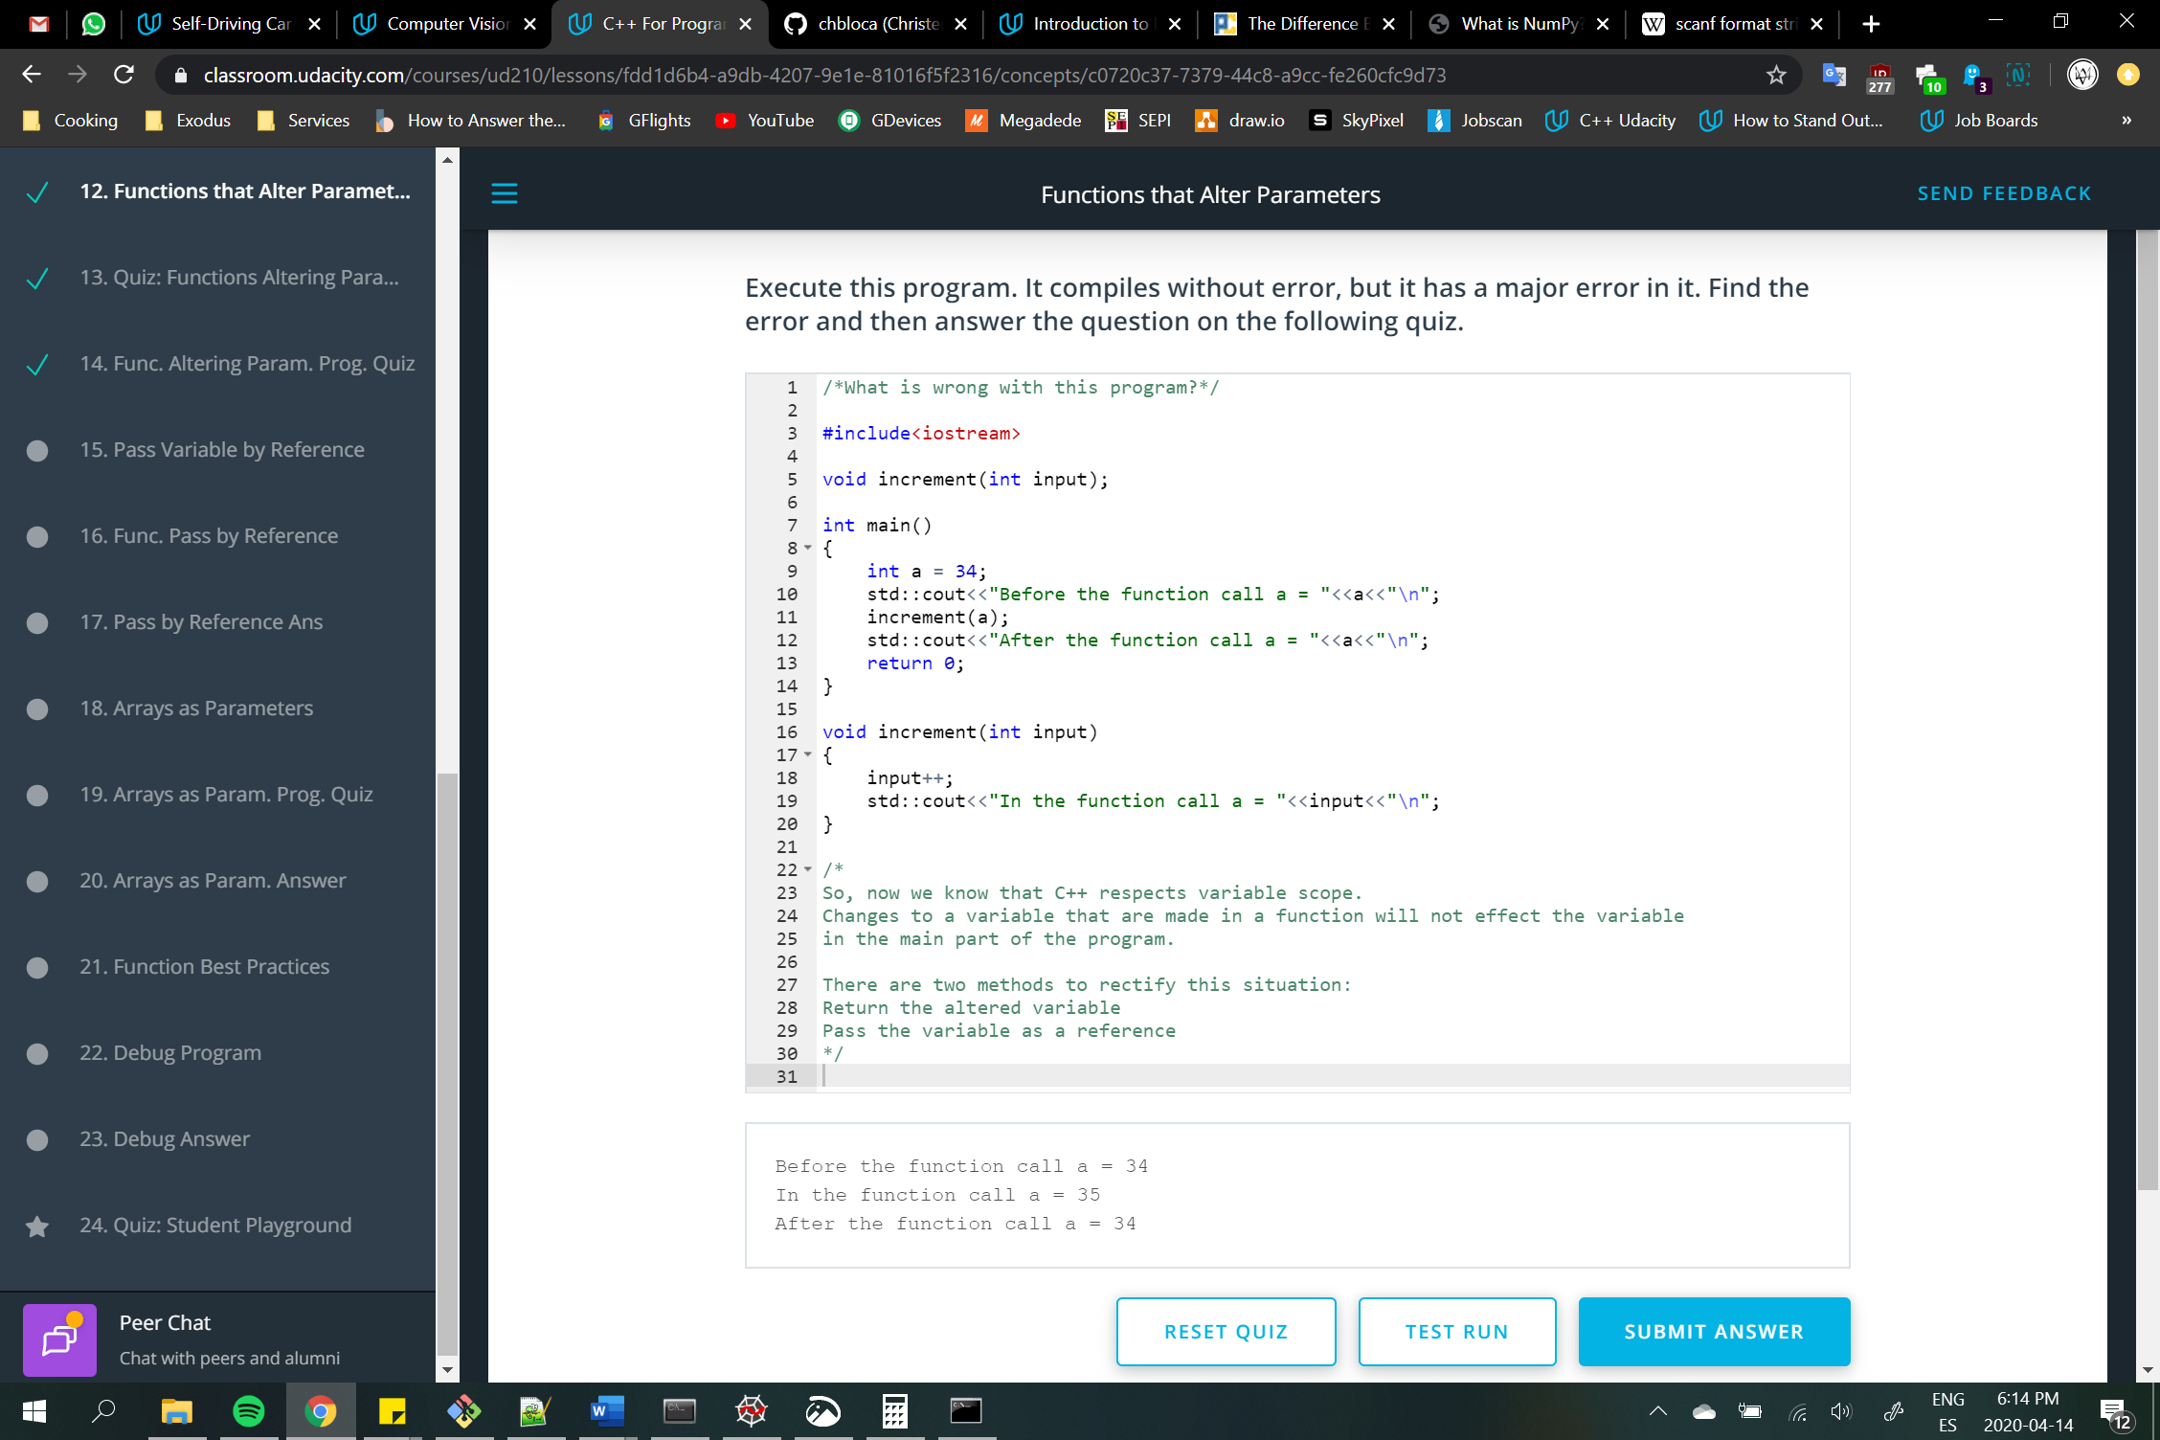

A class in C++ is a user defined data type. It can have data and functions.

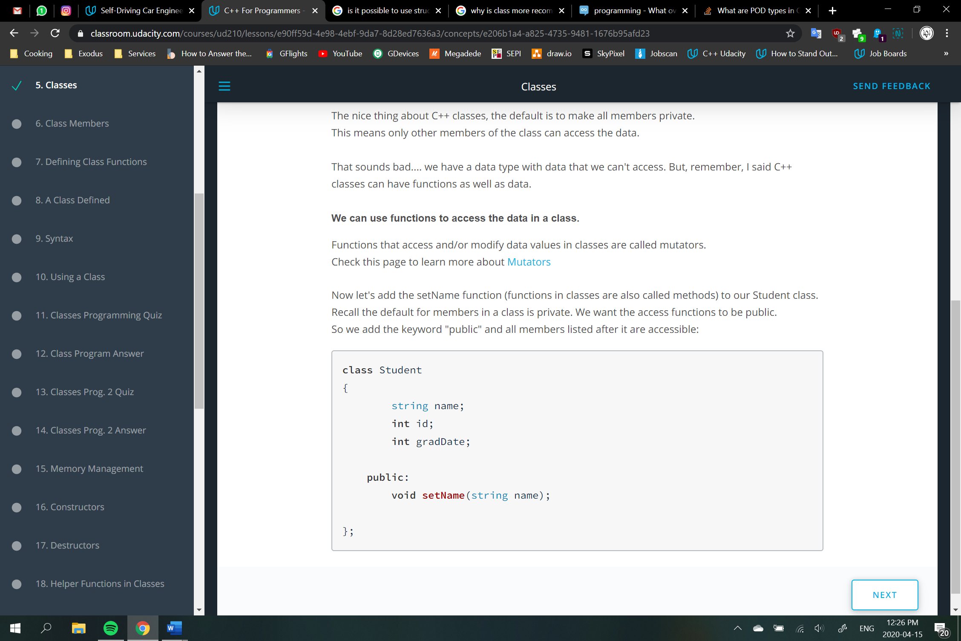

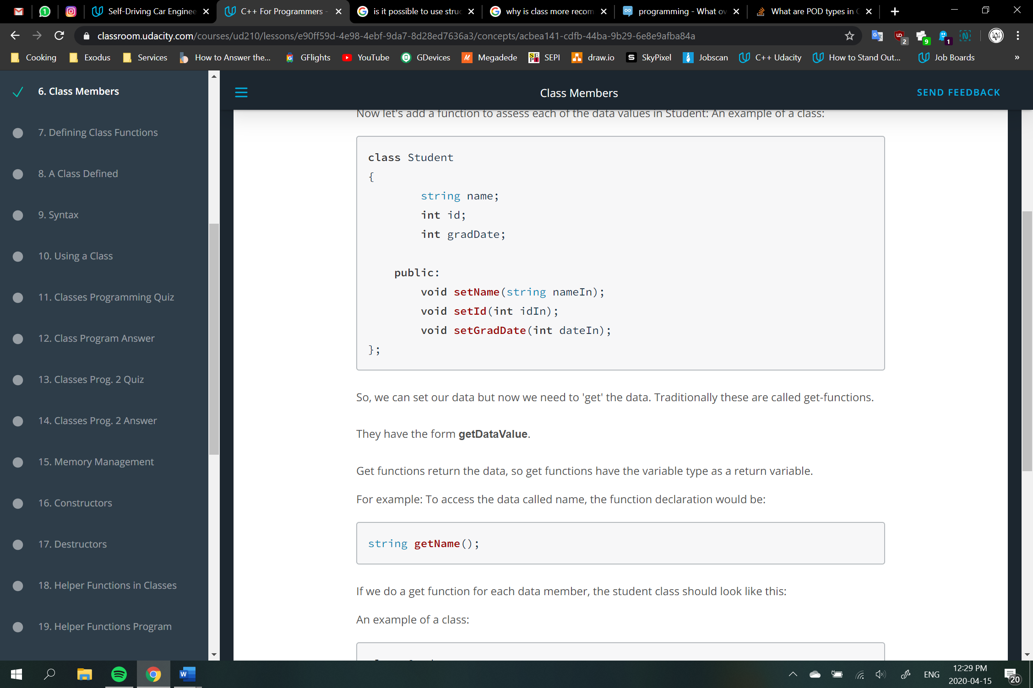

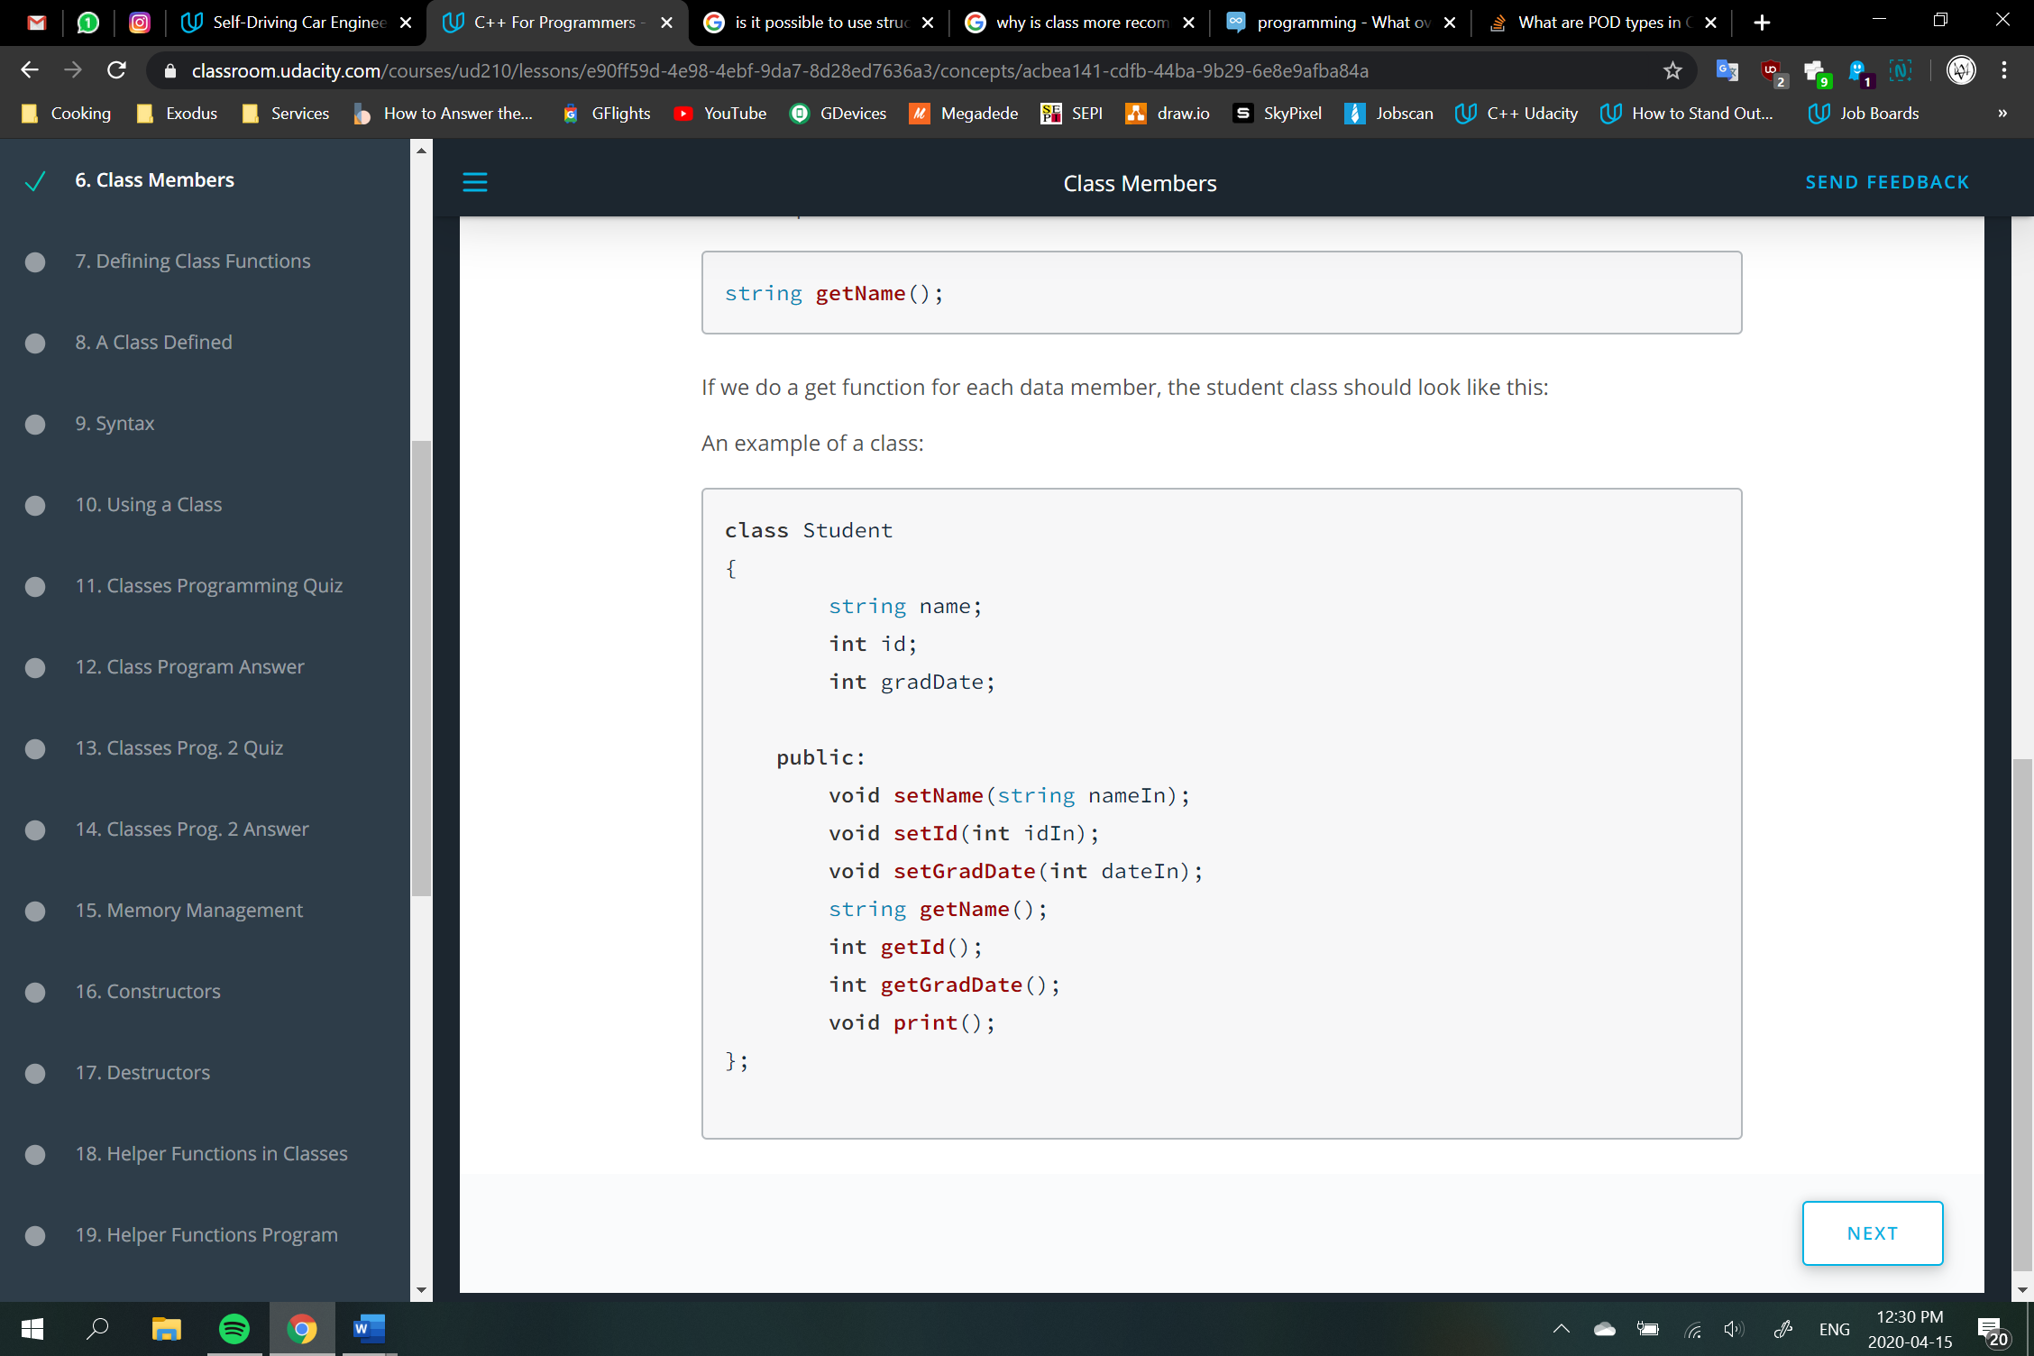

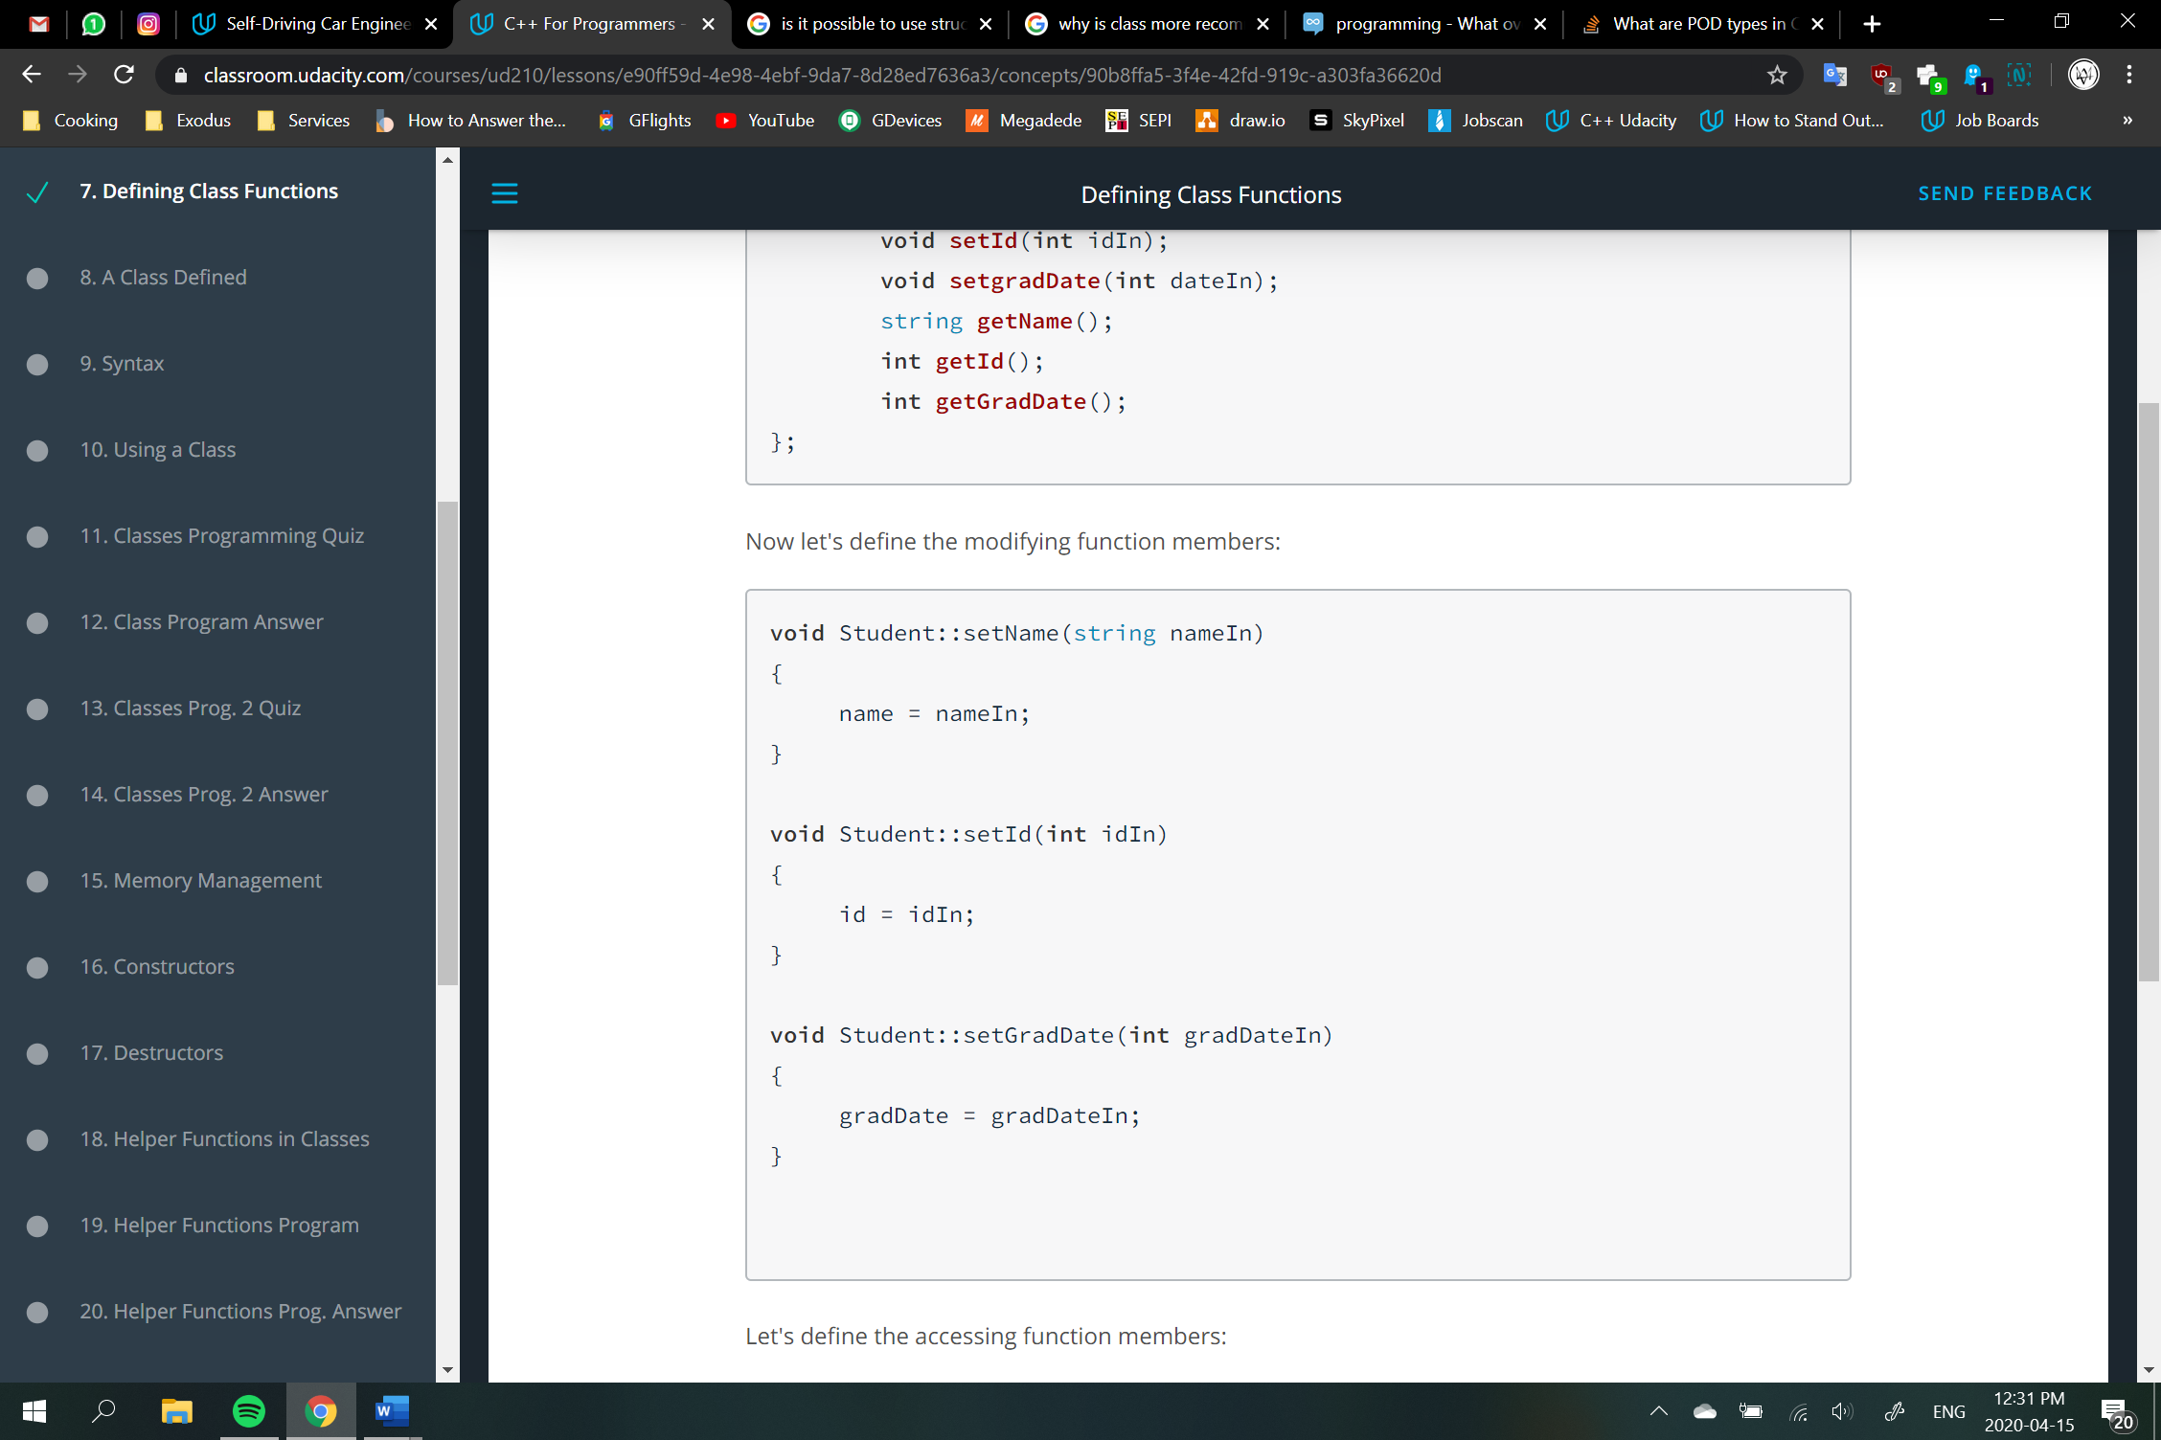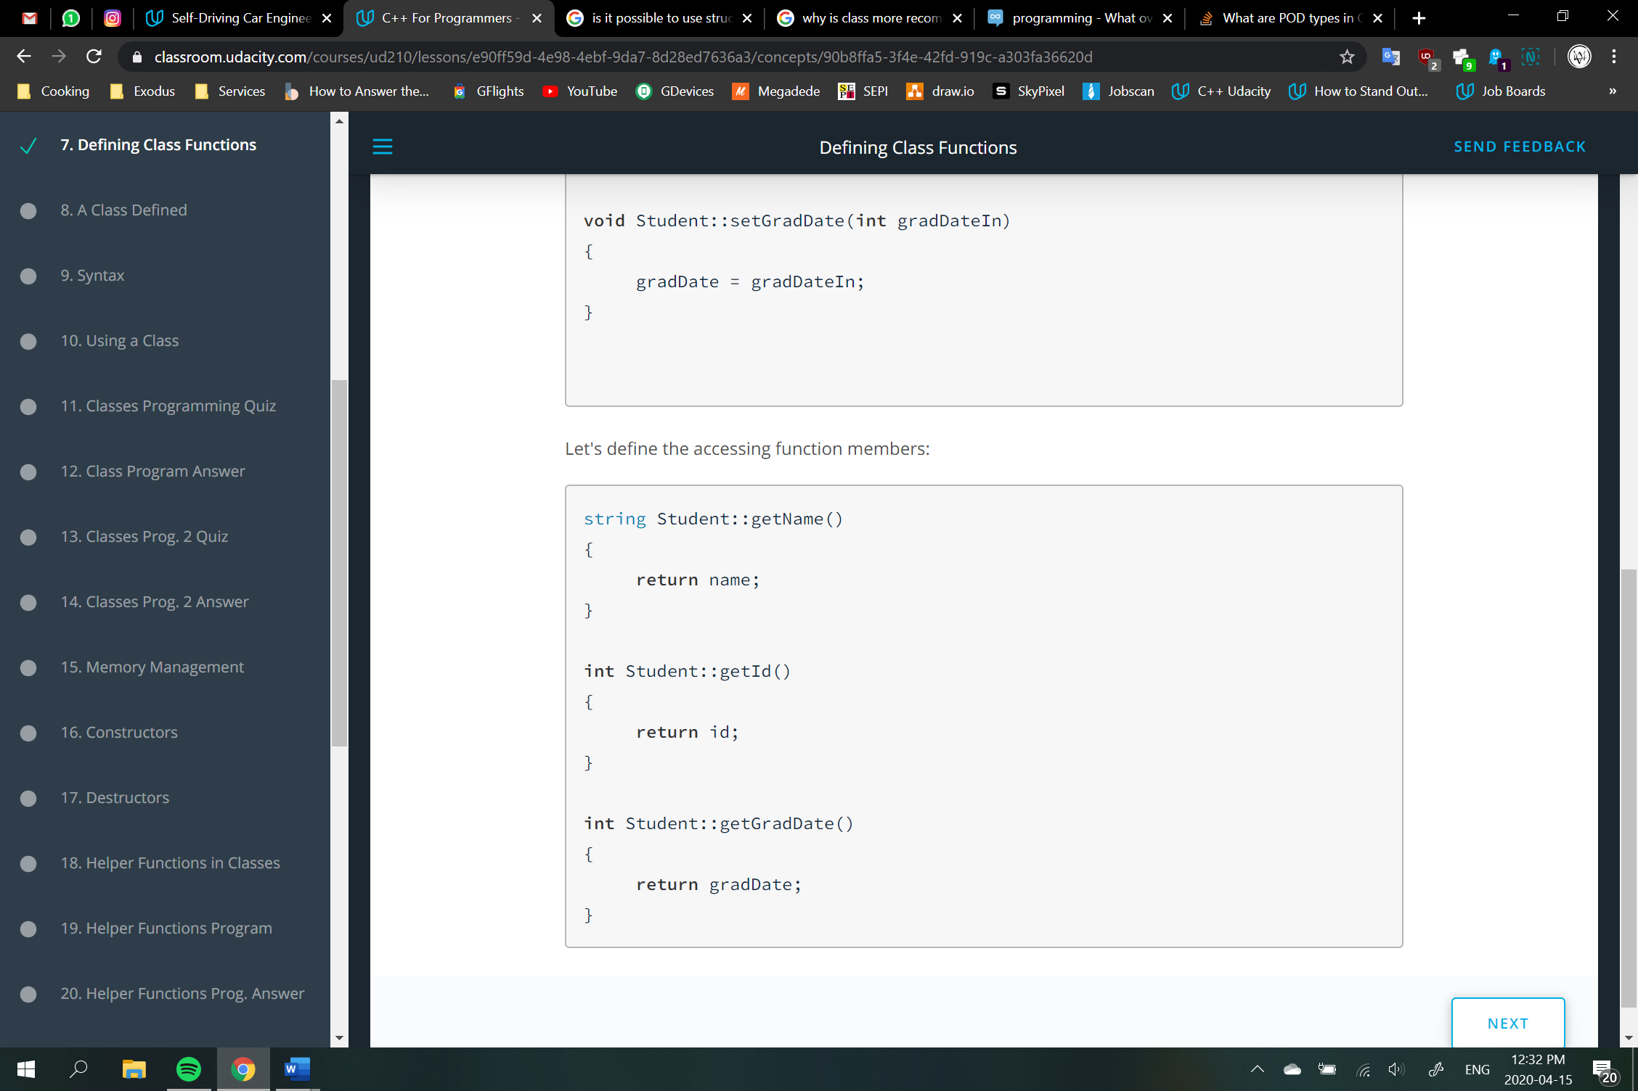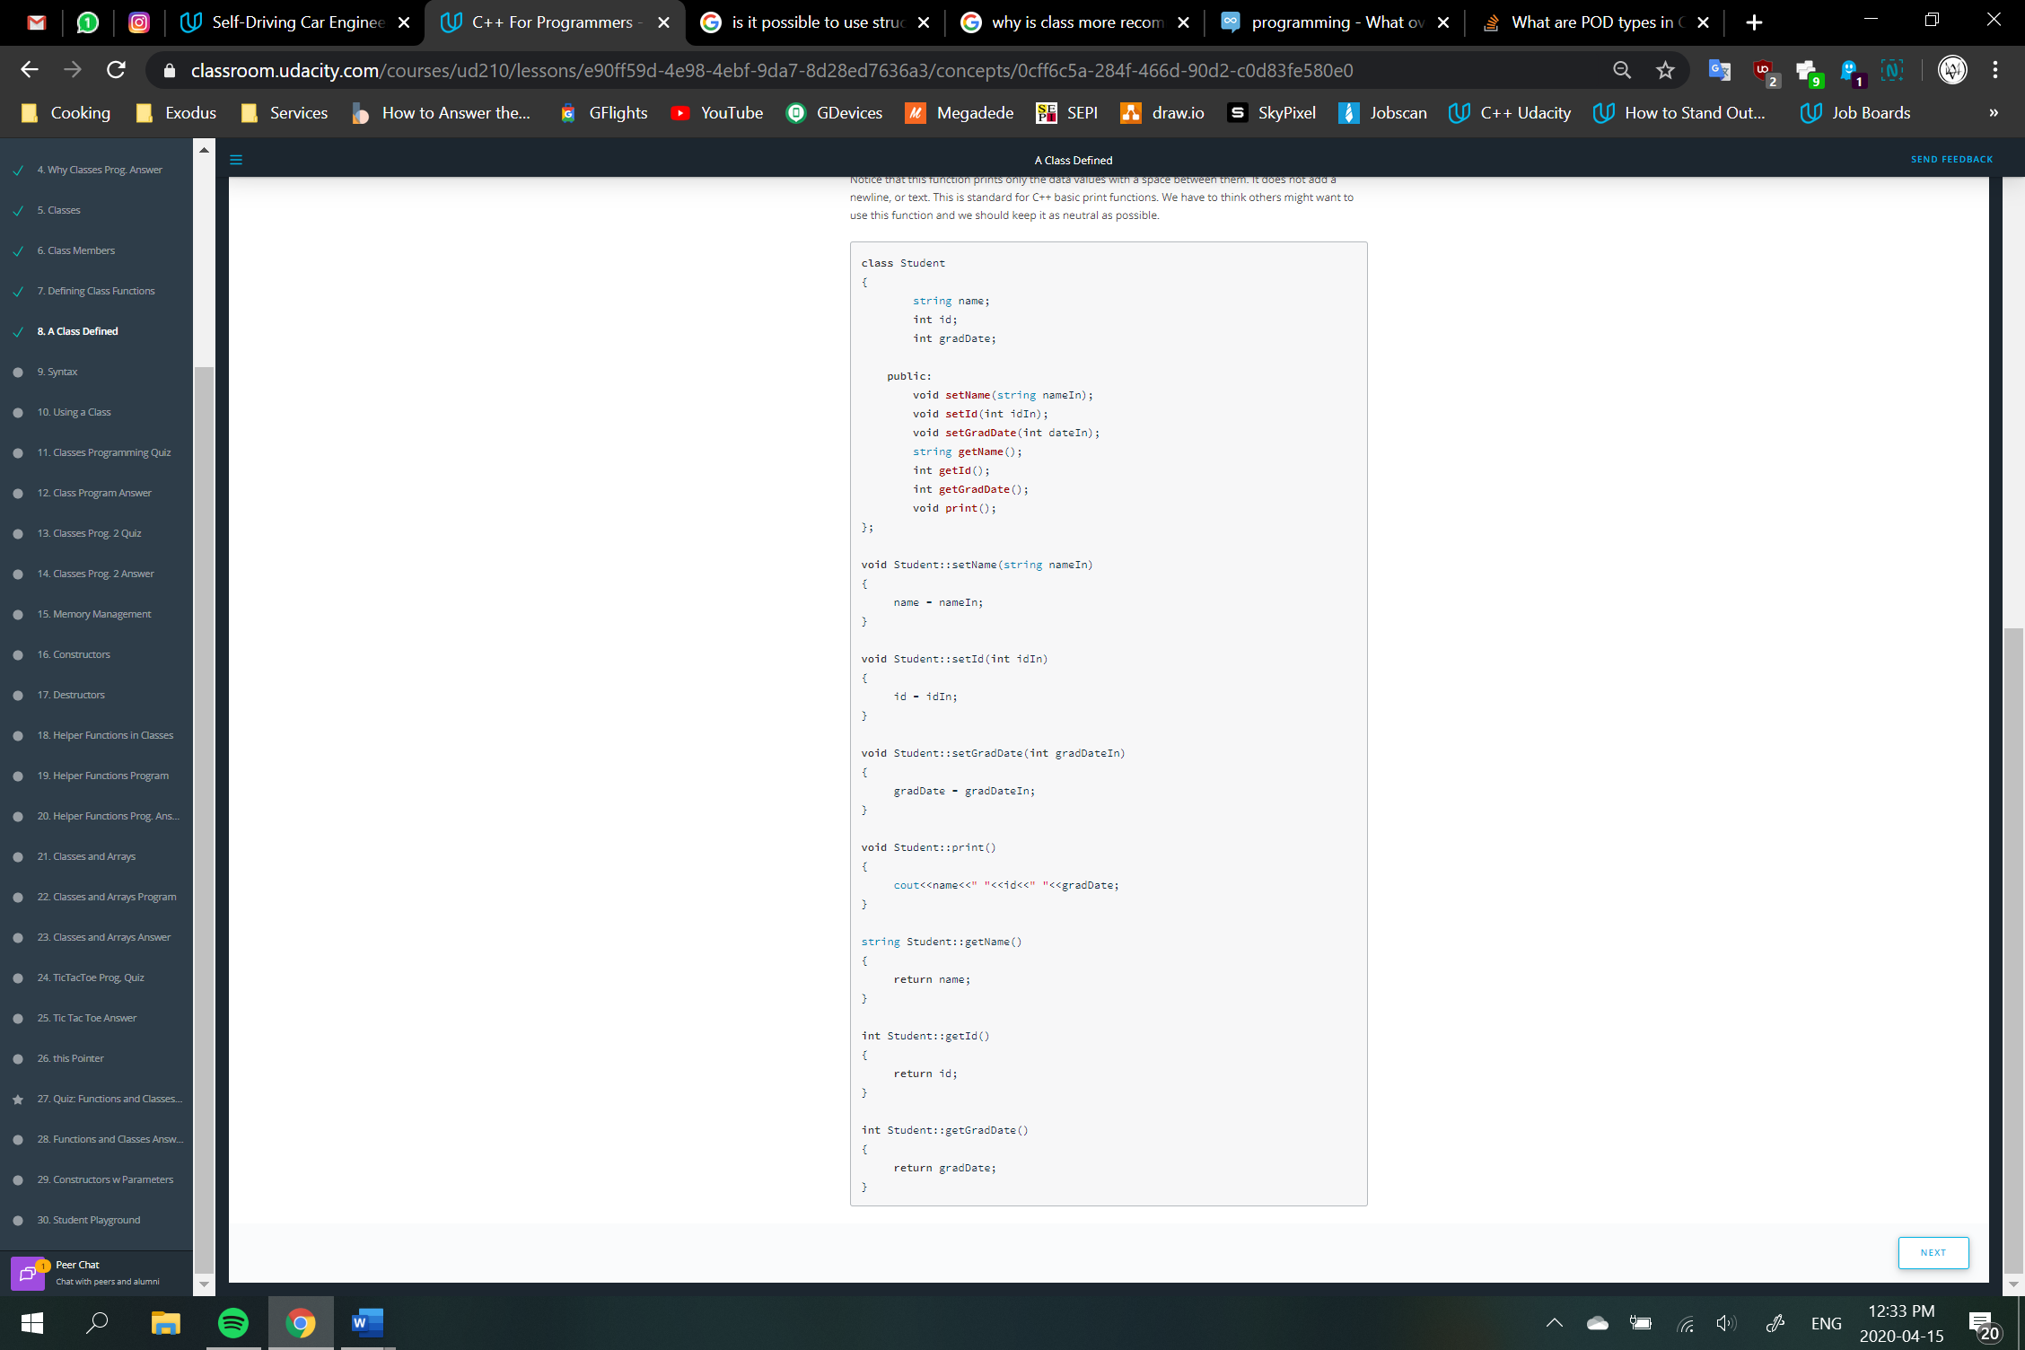

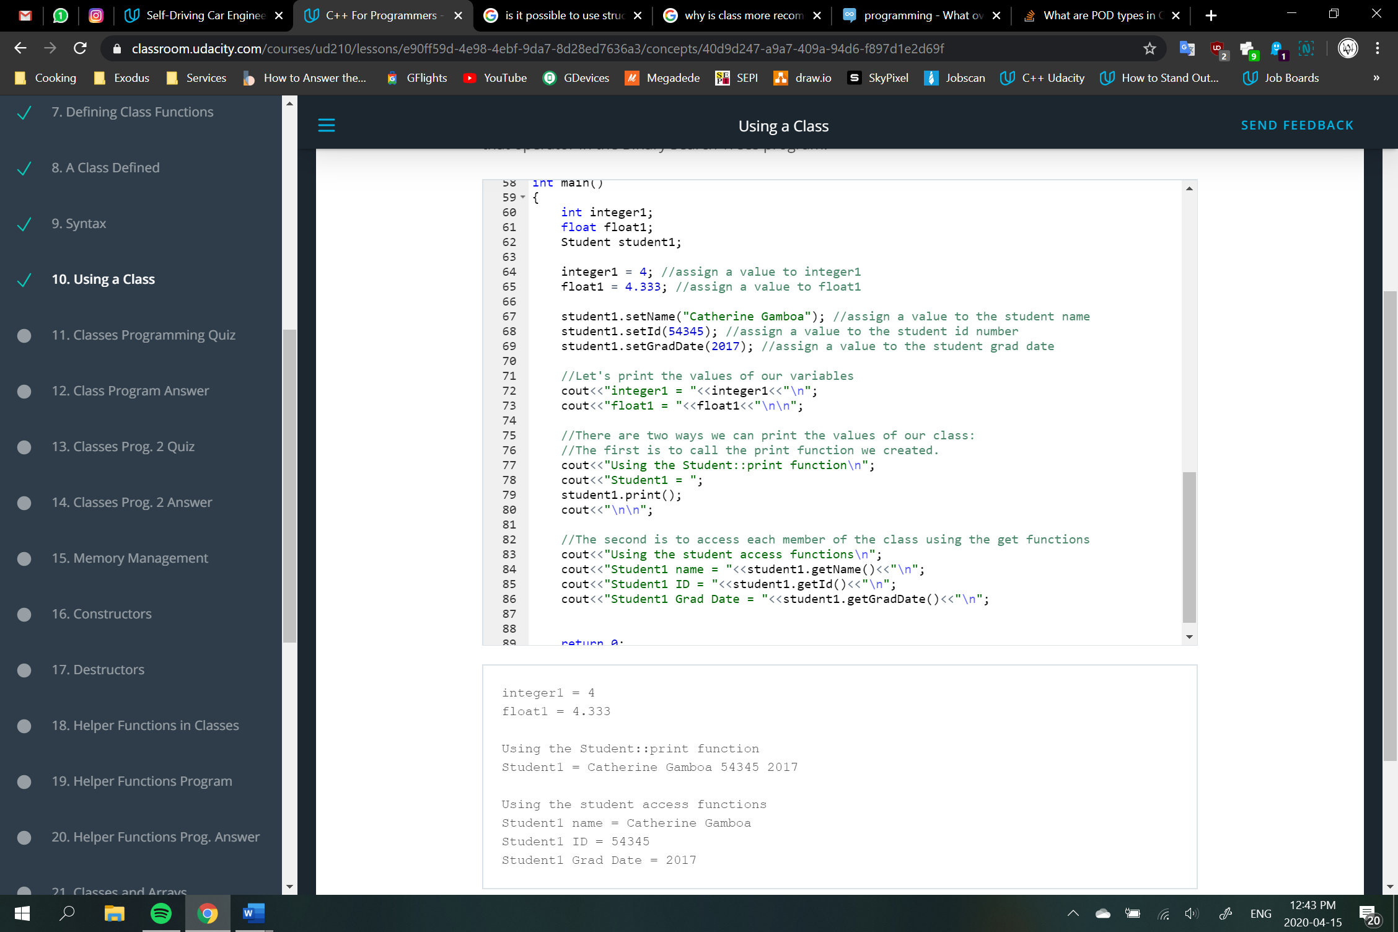

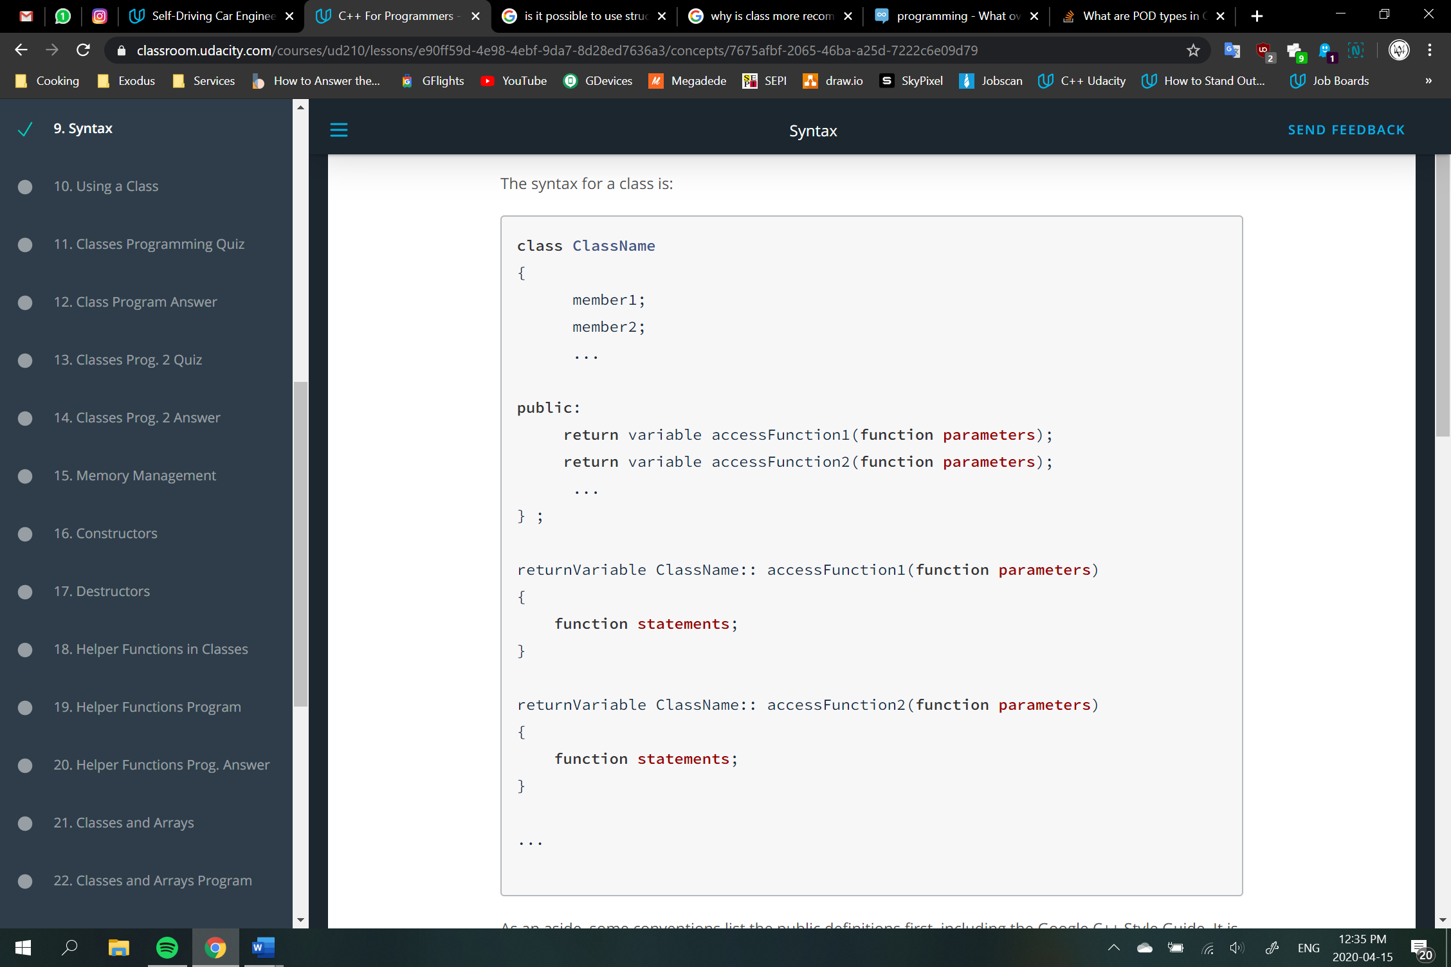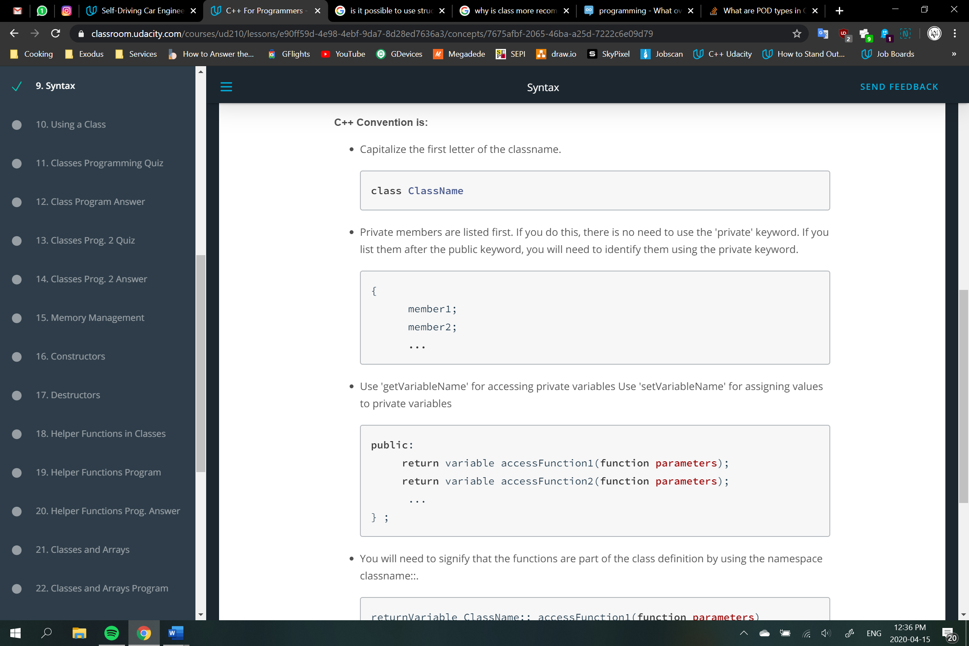

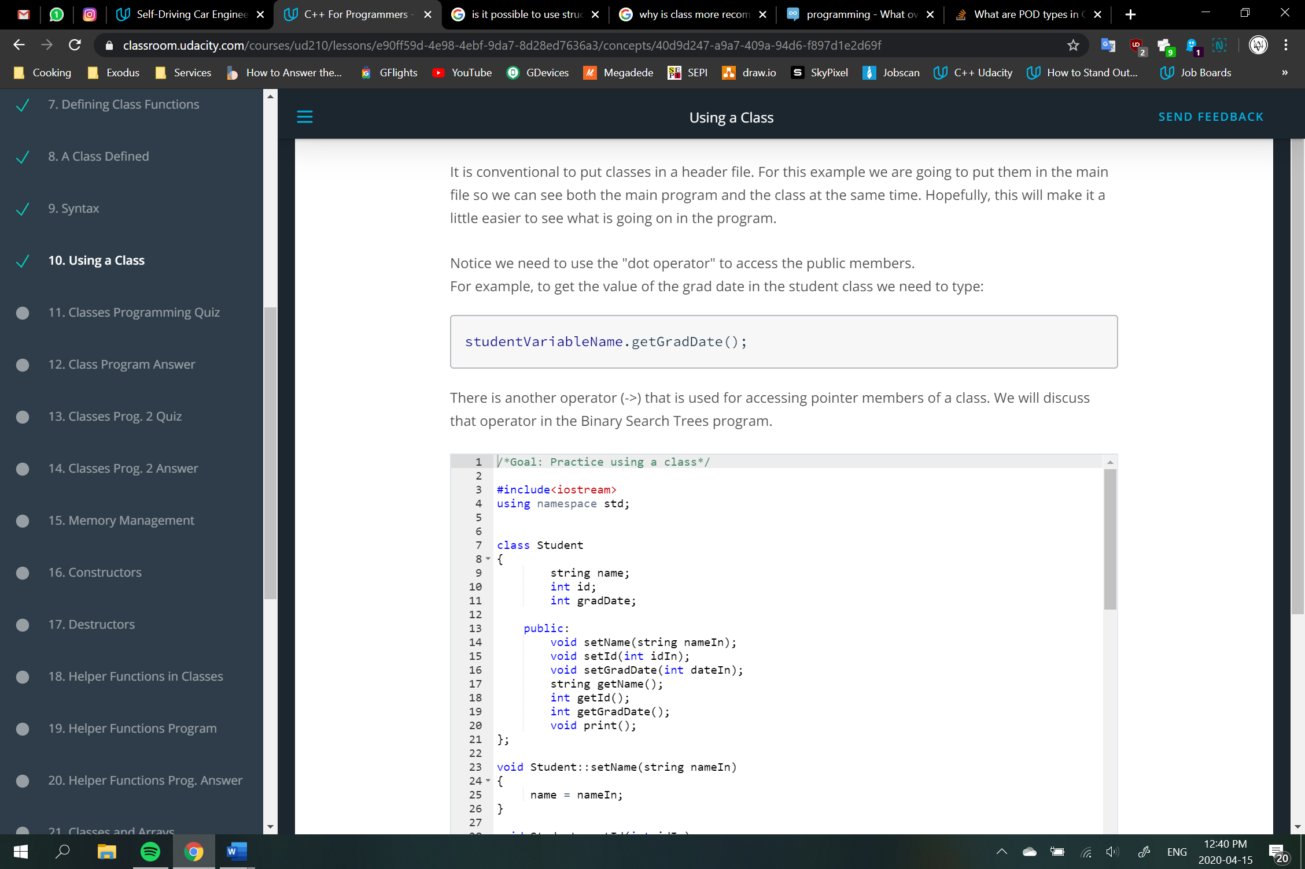

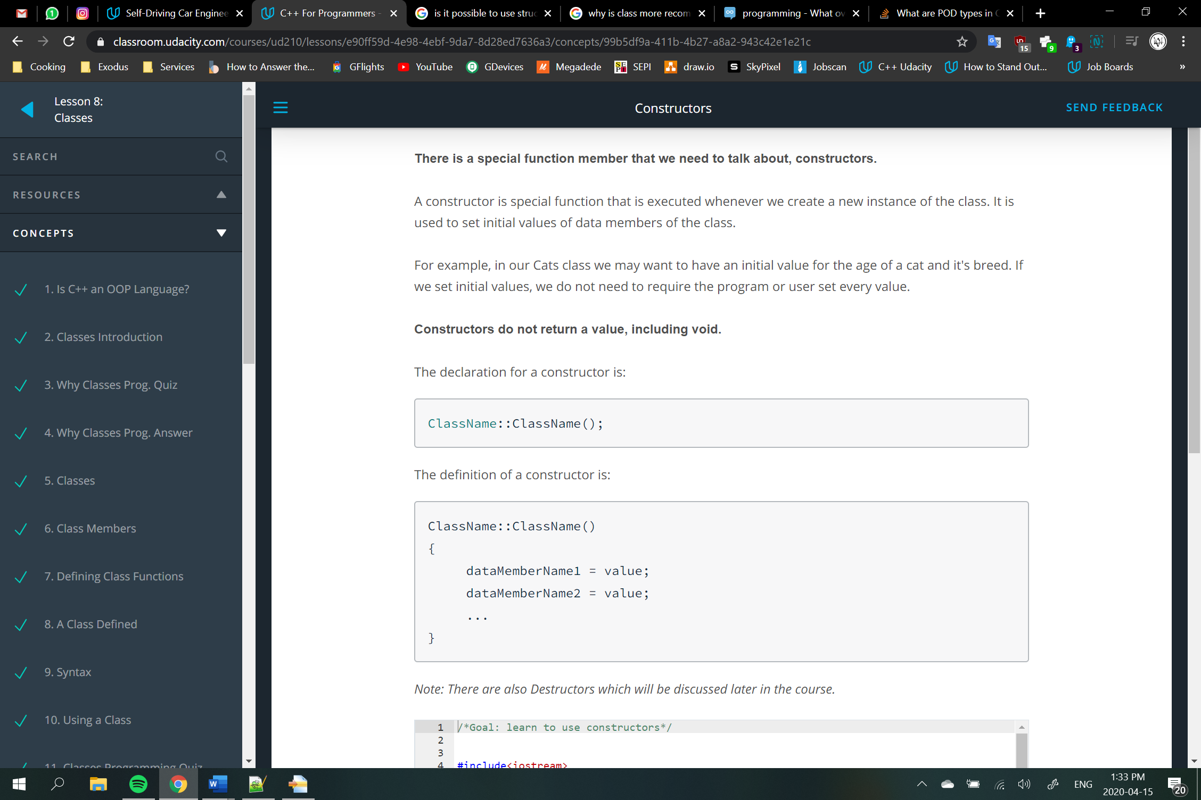

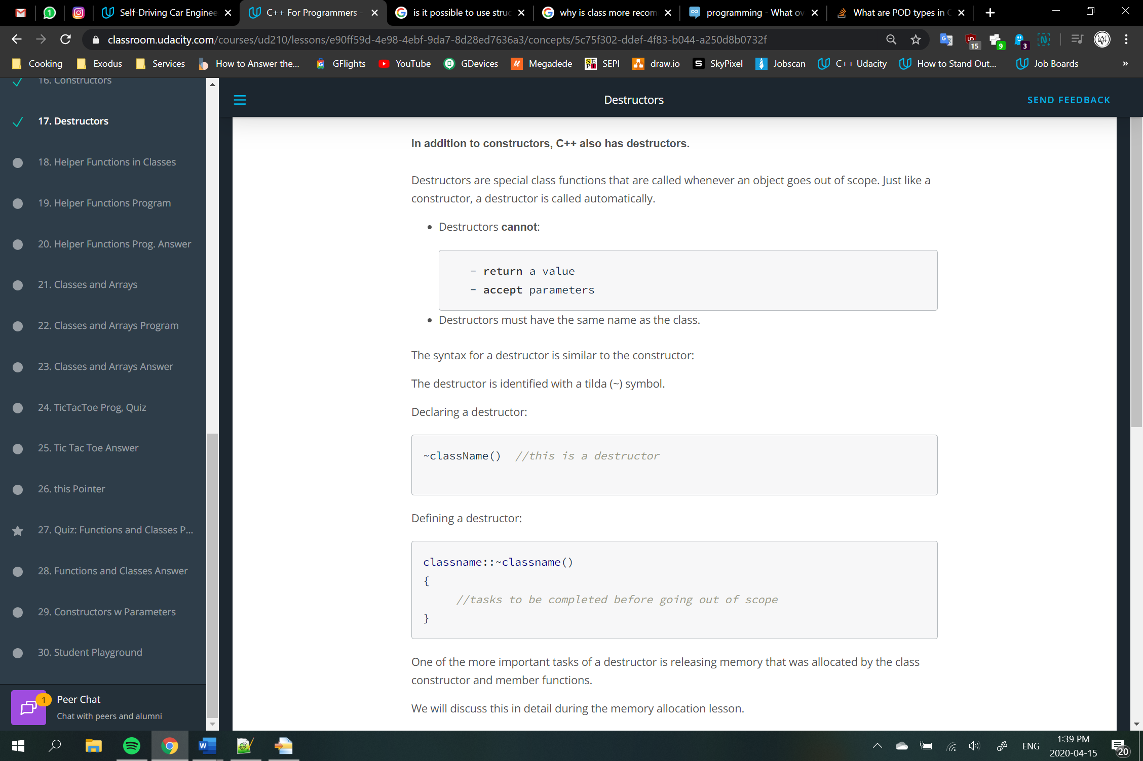

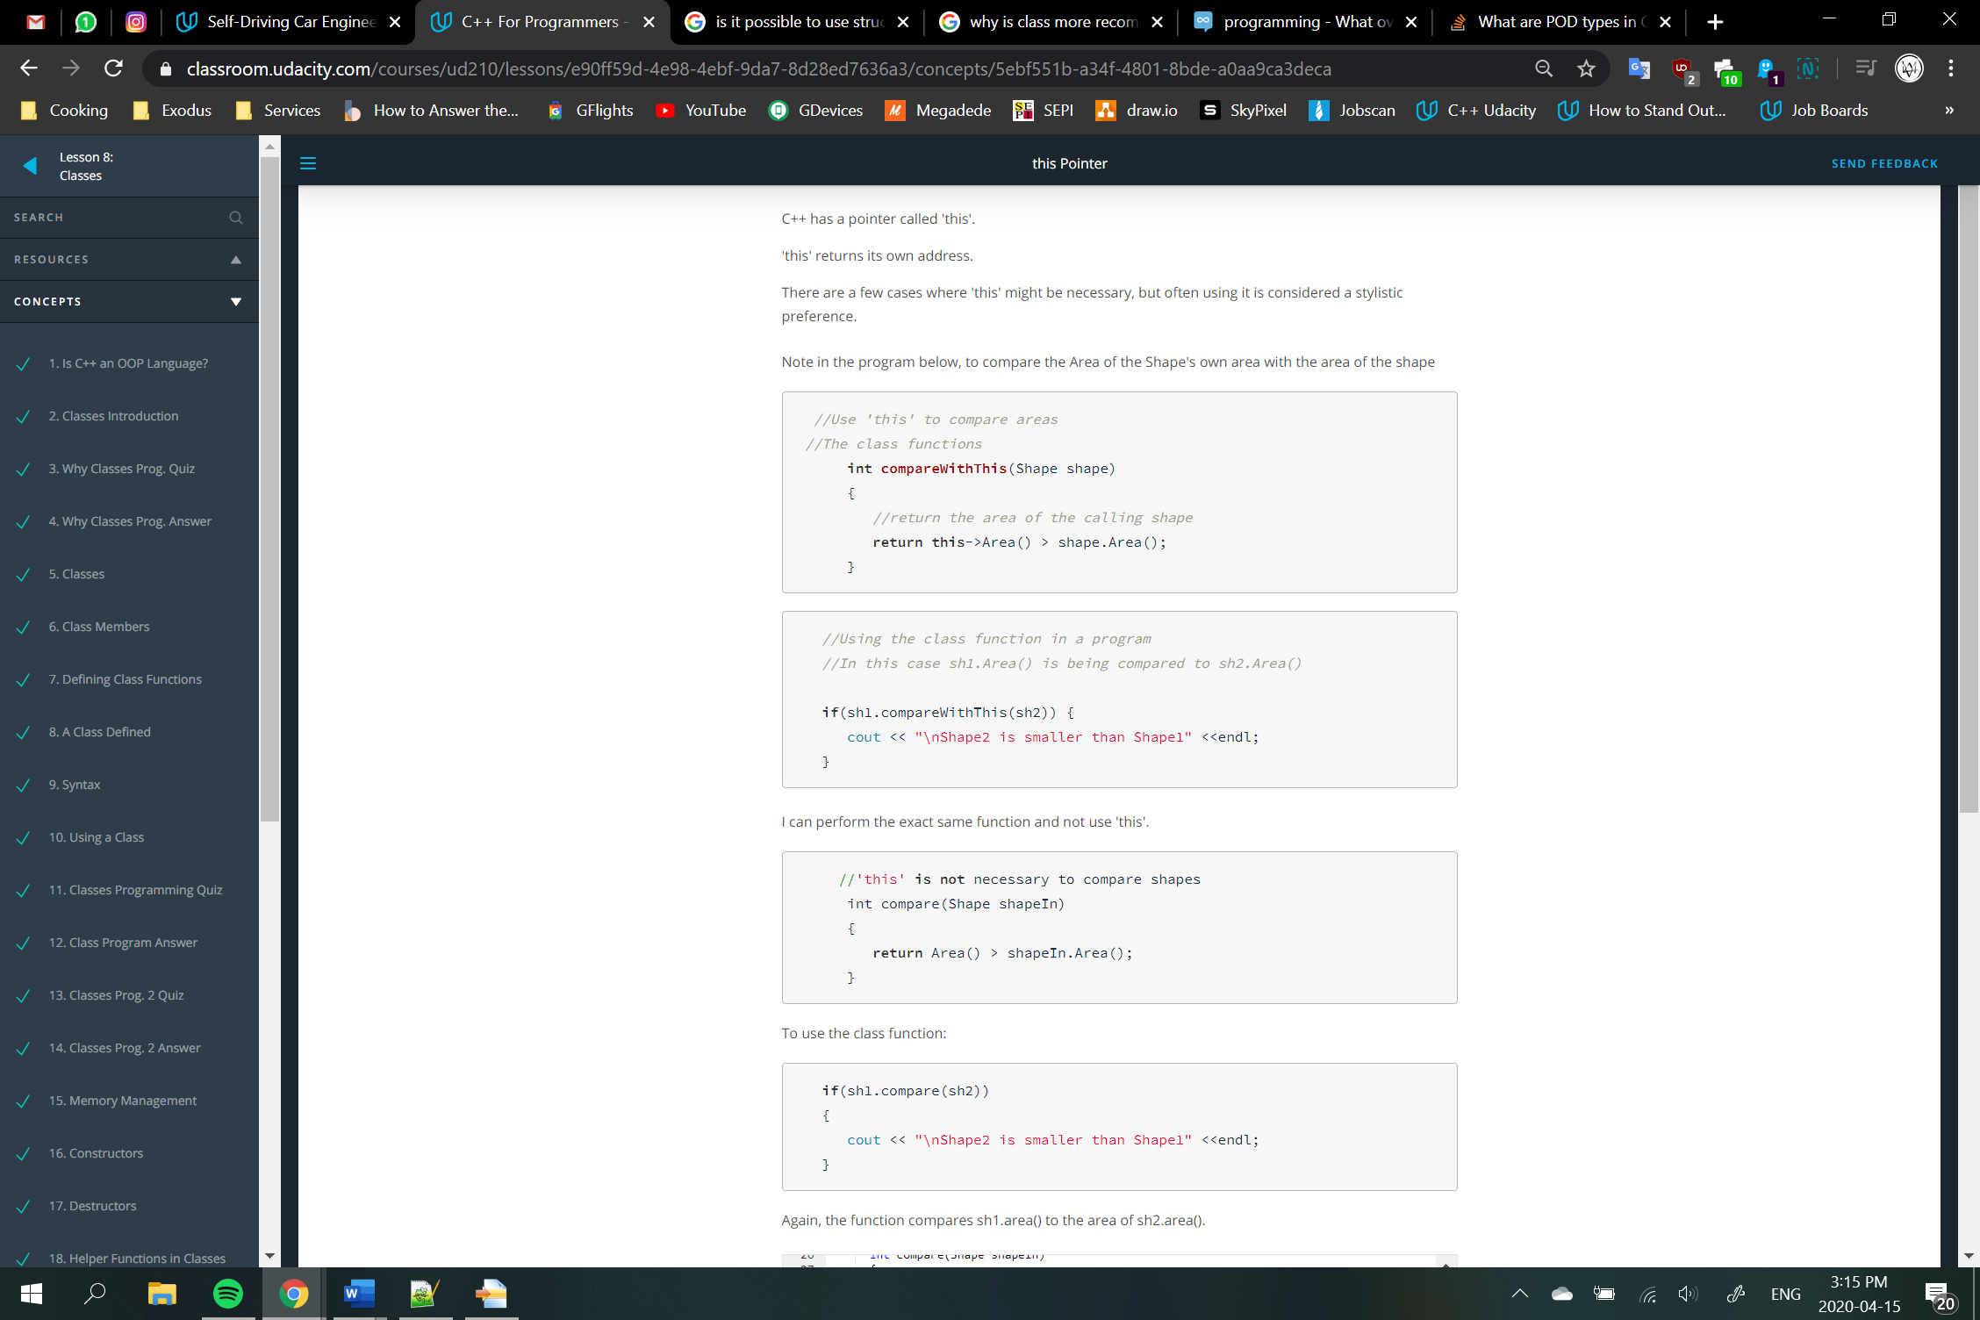

C++ allows class constructors to accept parameters. These parameters will set the values of class members when the object is created. Without using setFunctions.

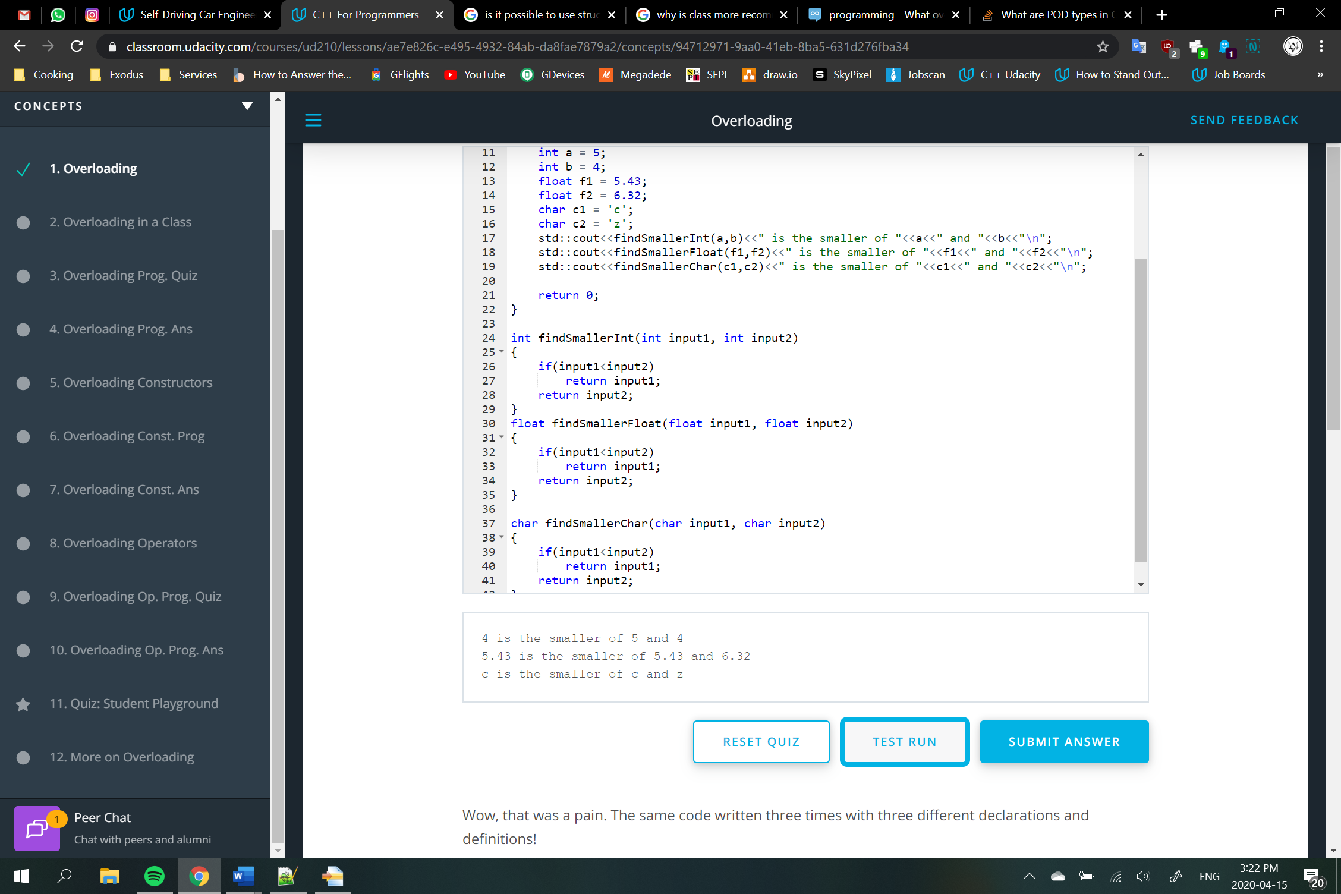

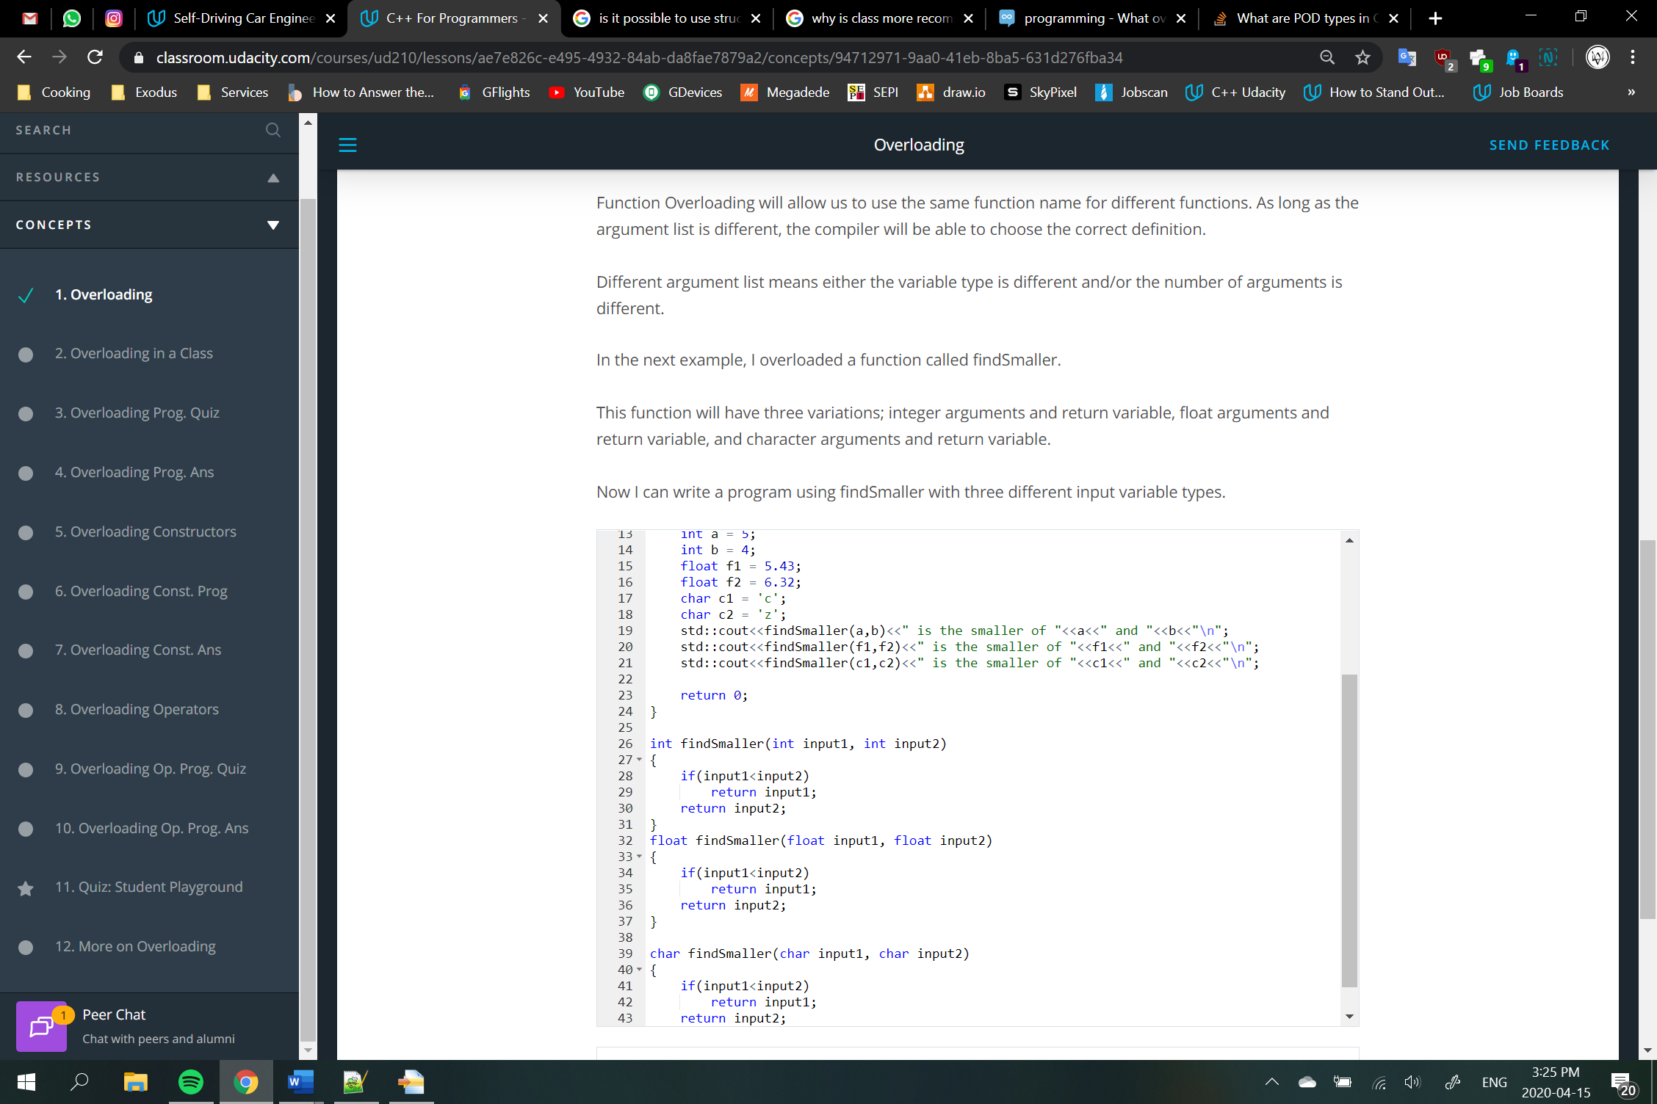

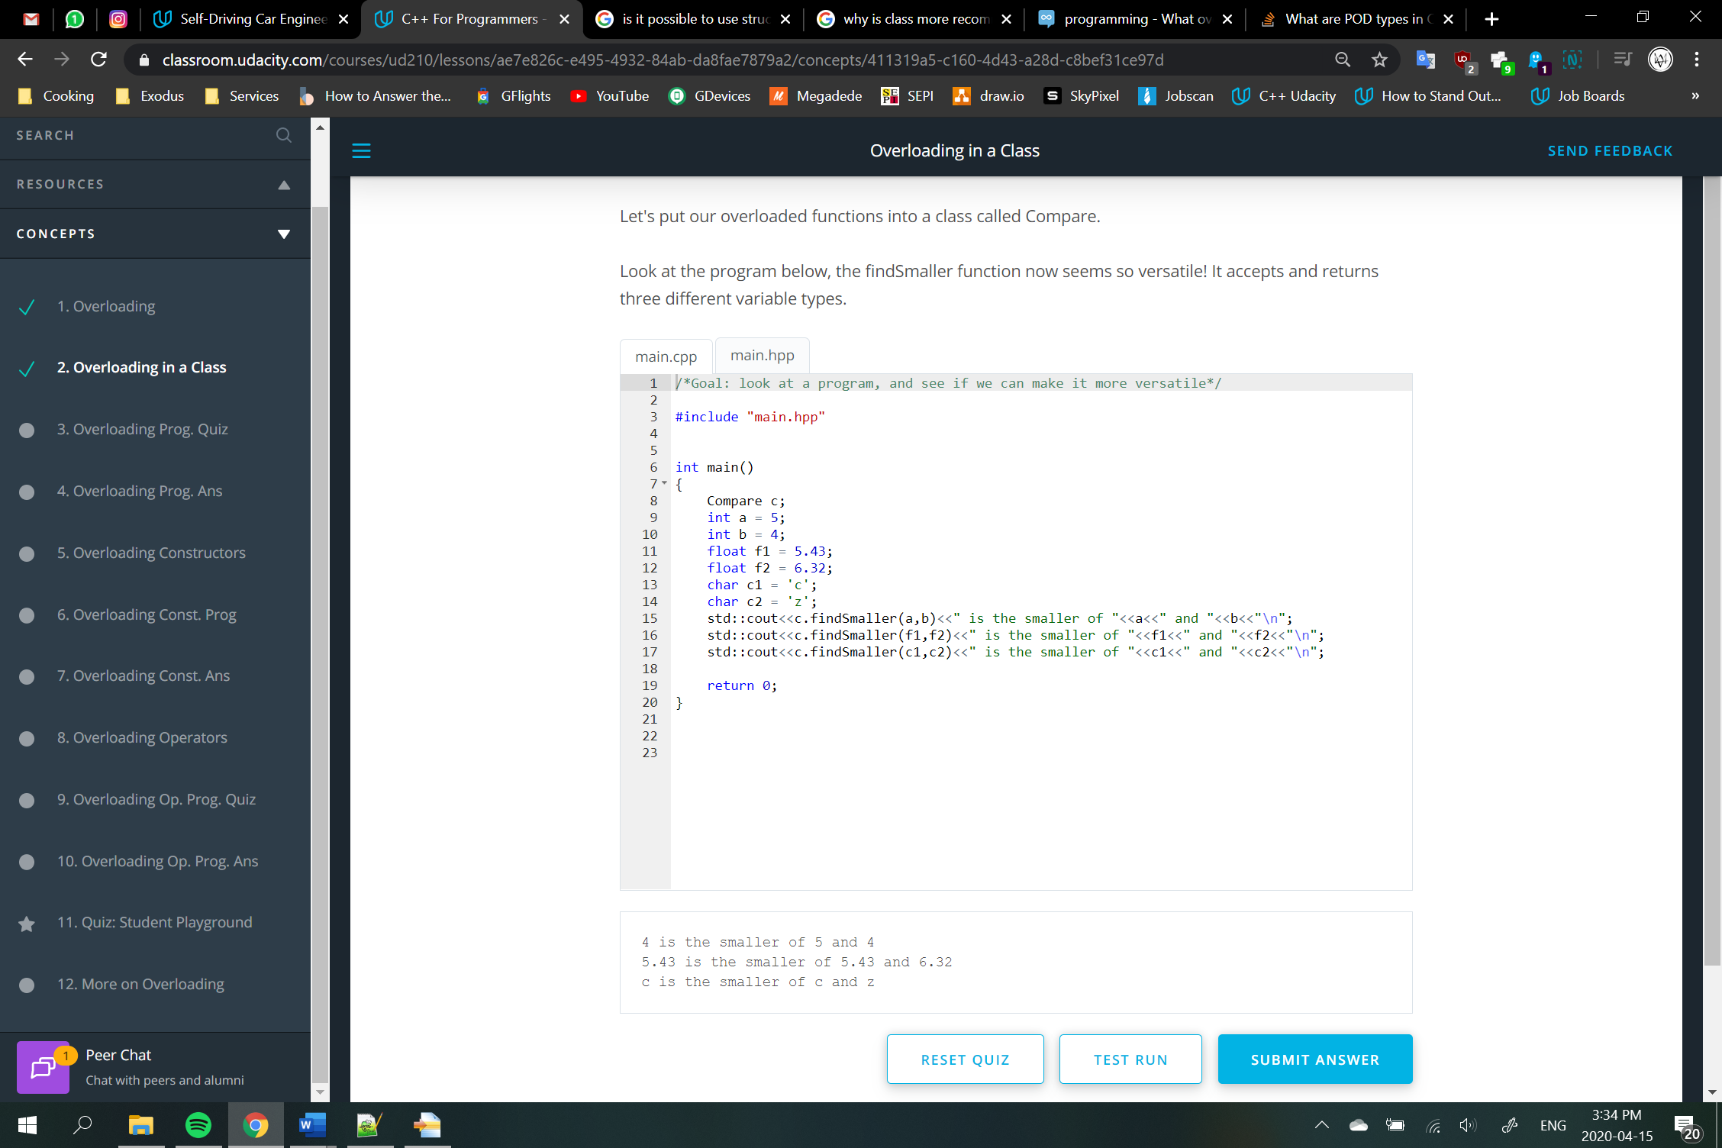

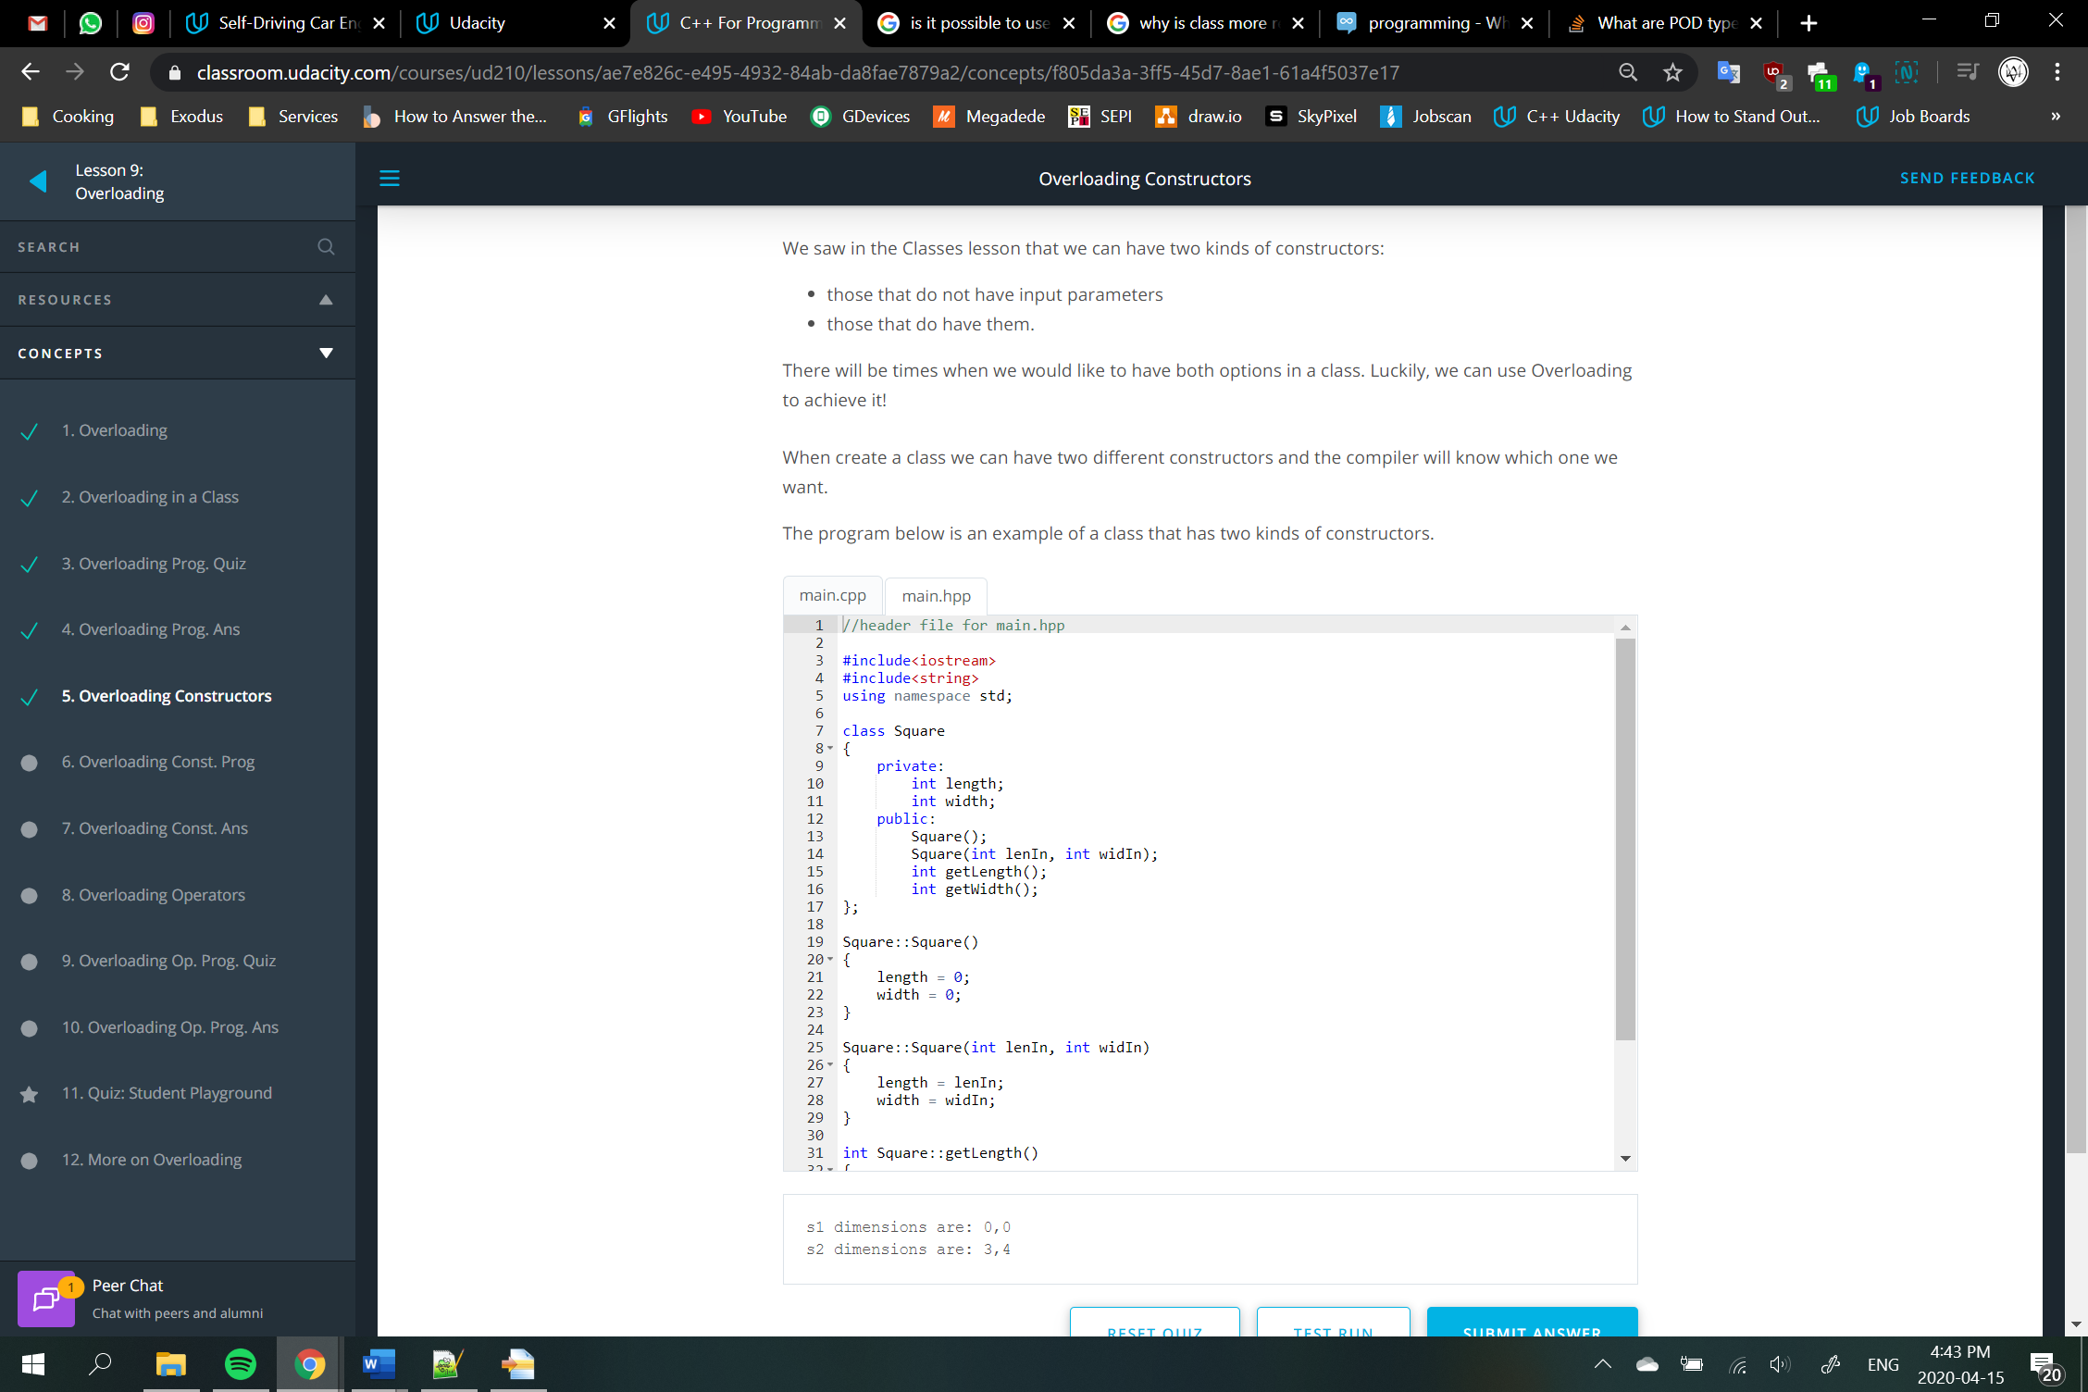

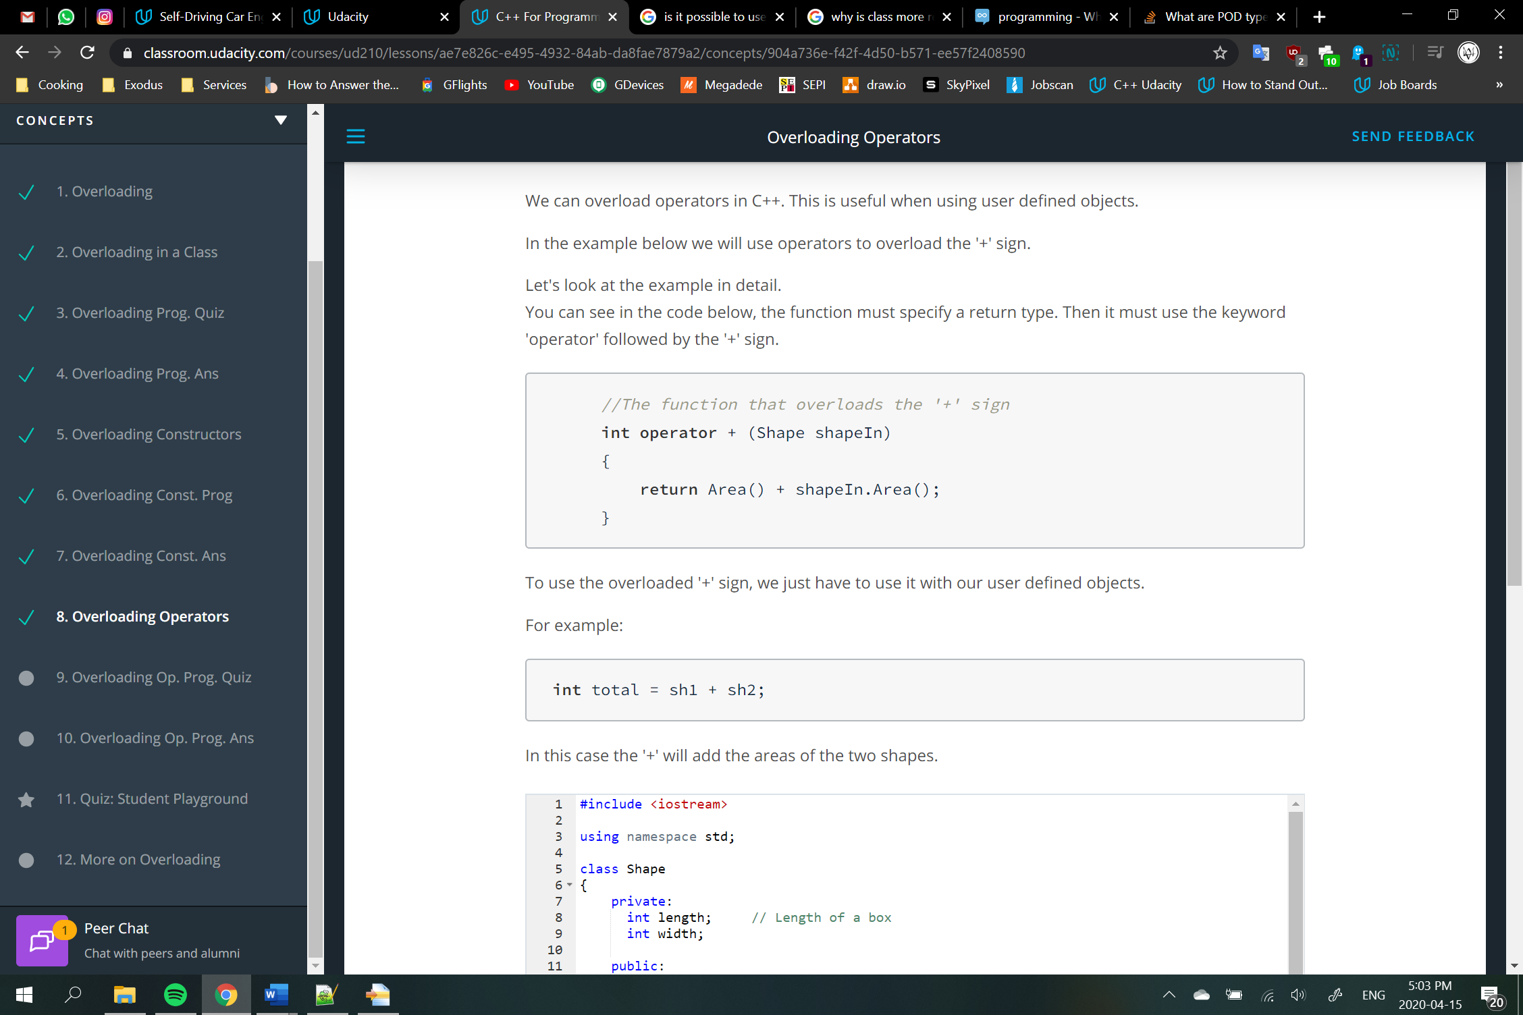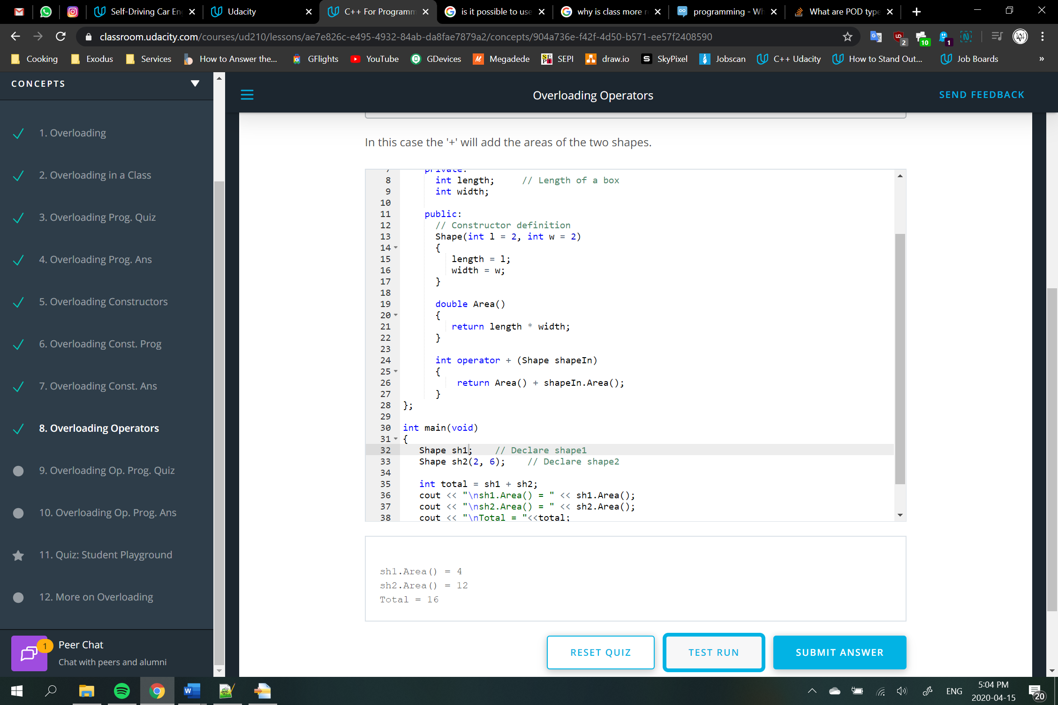

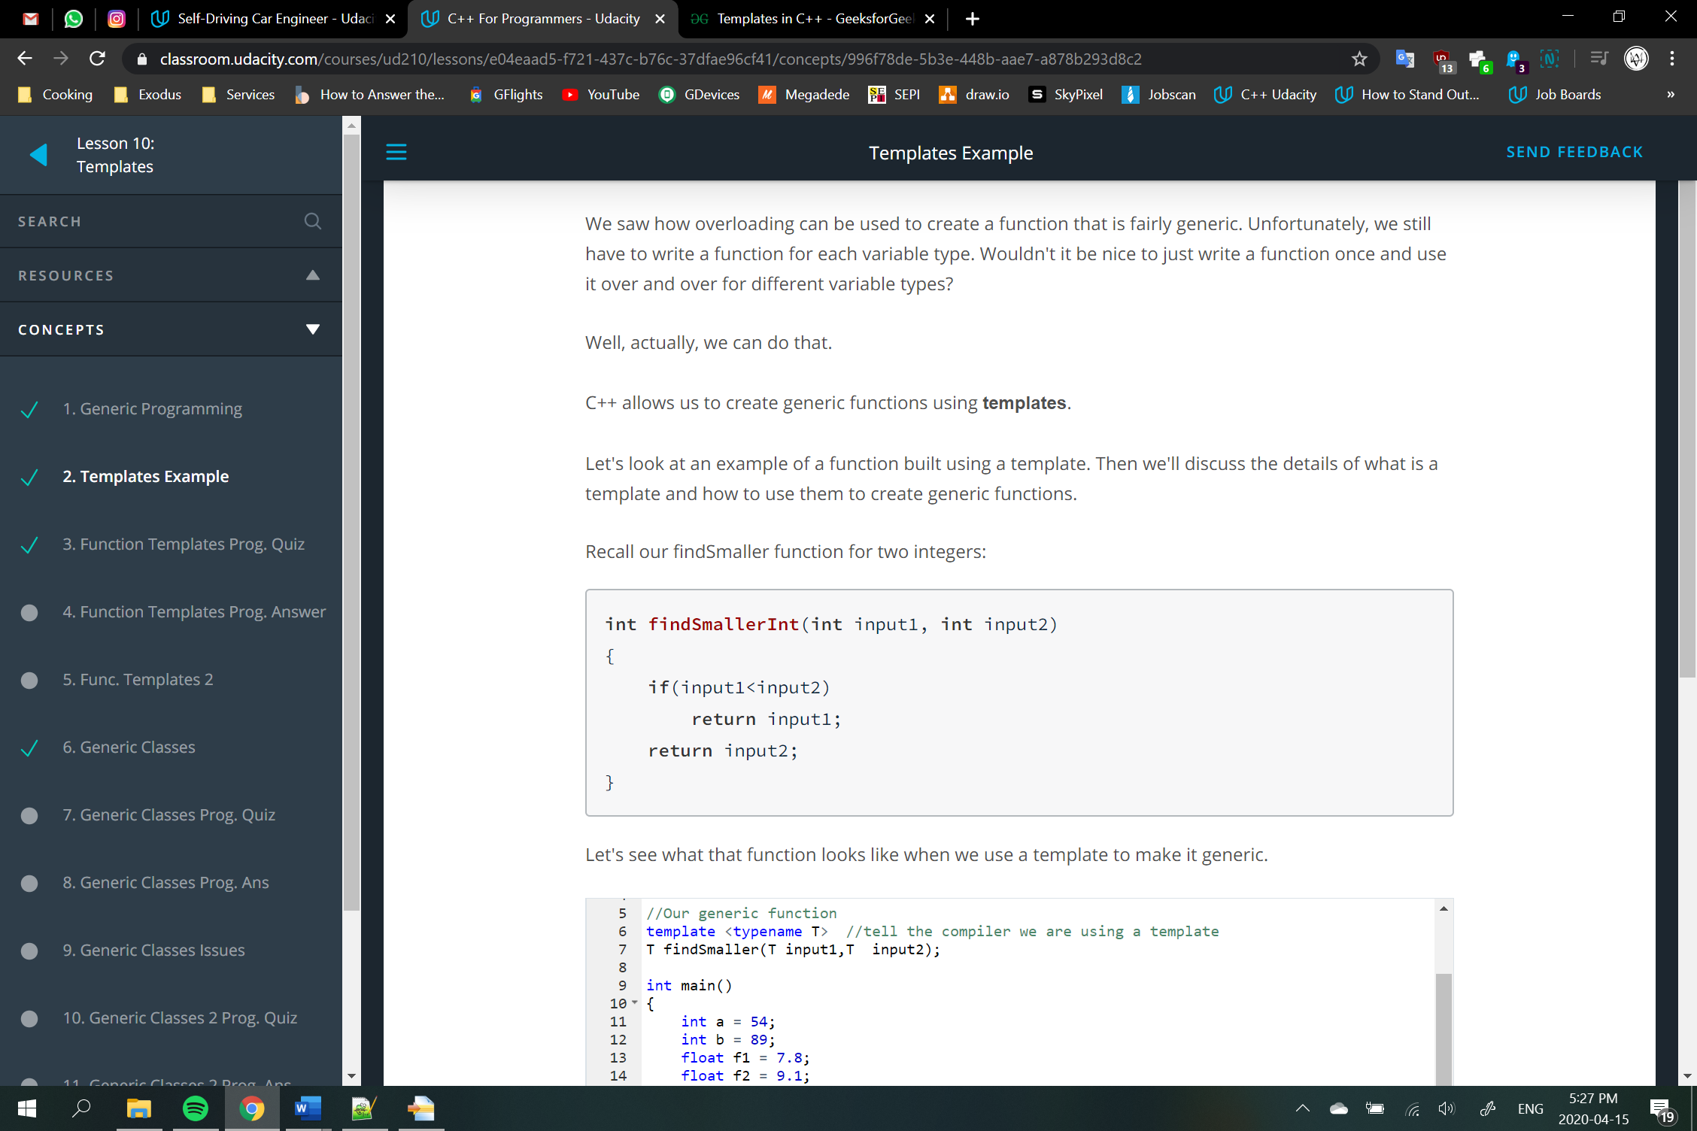

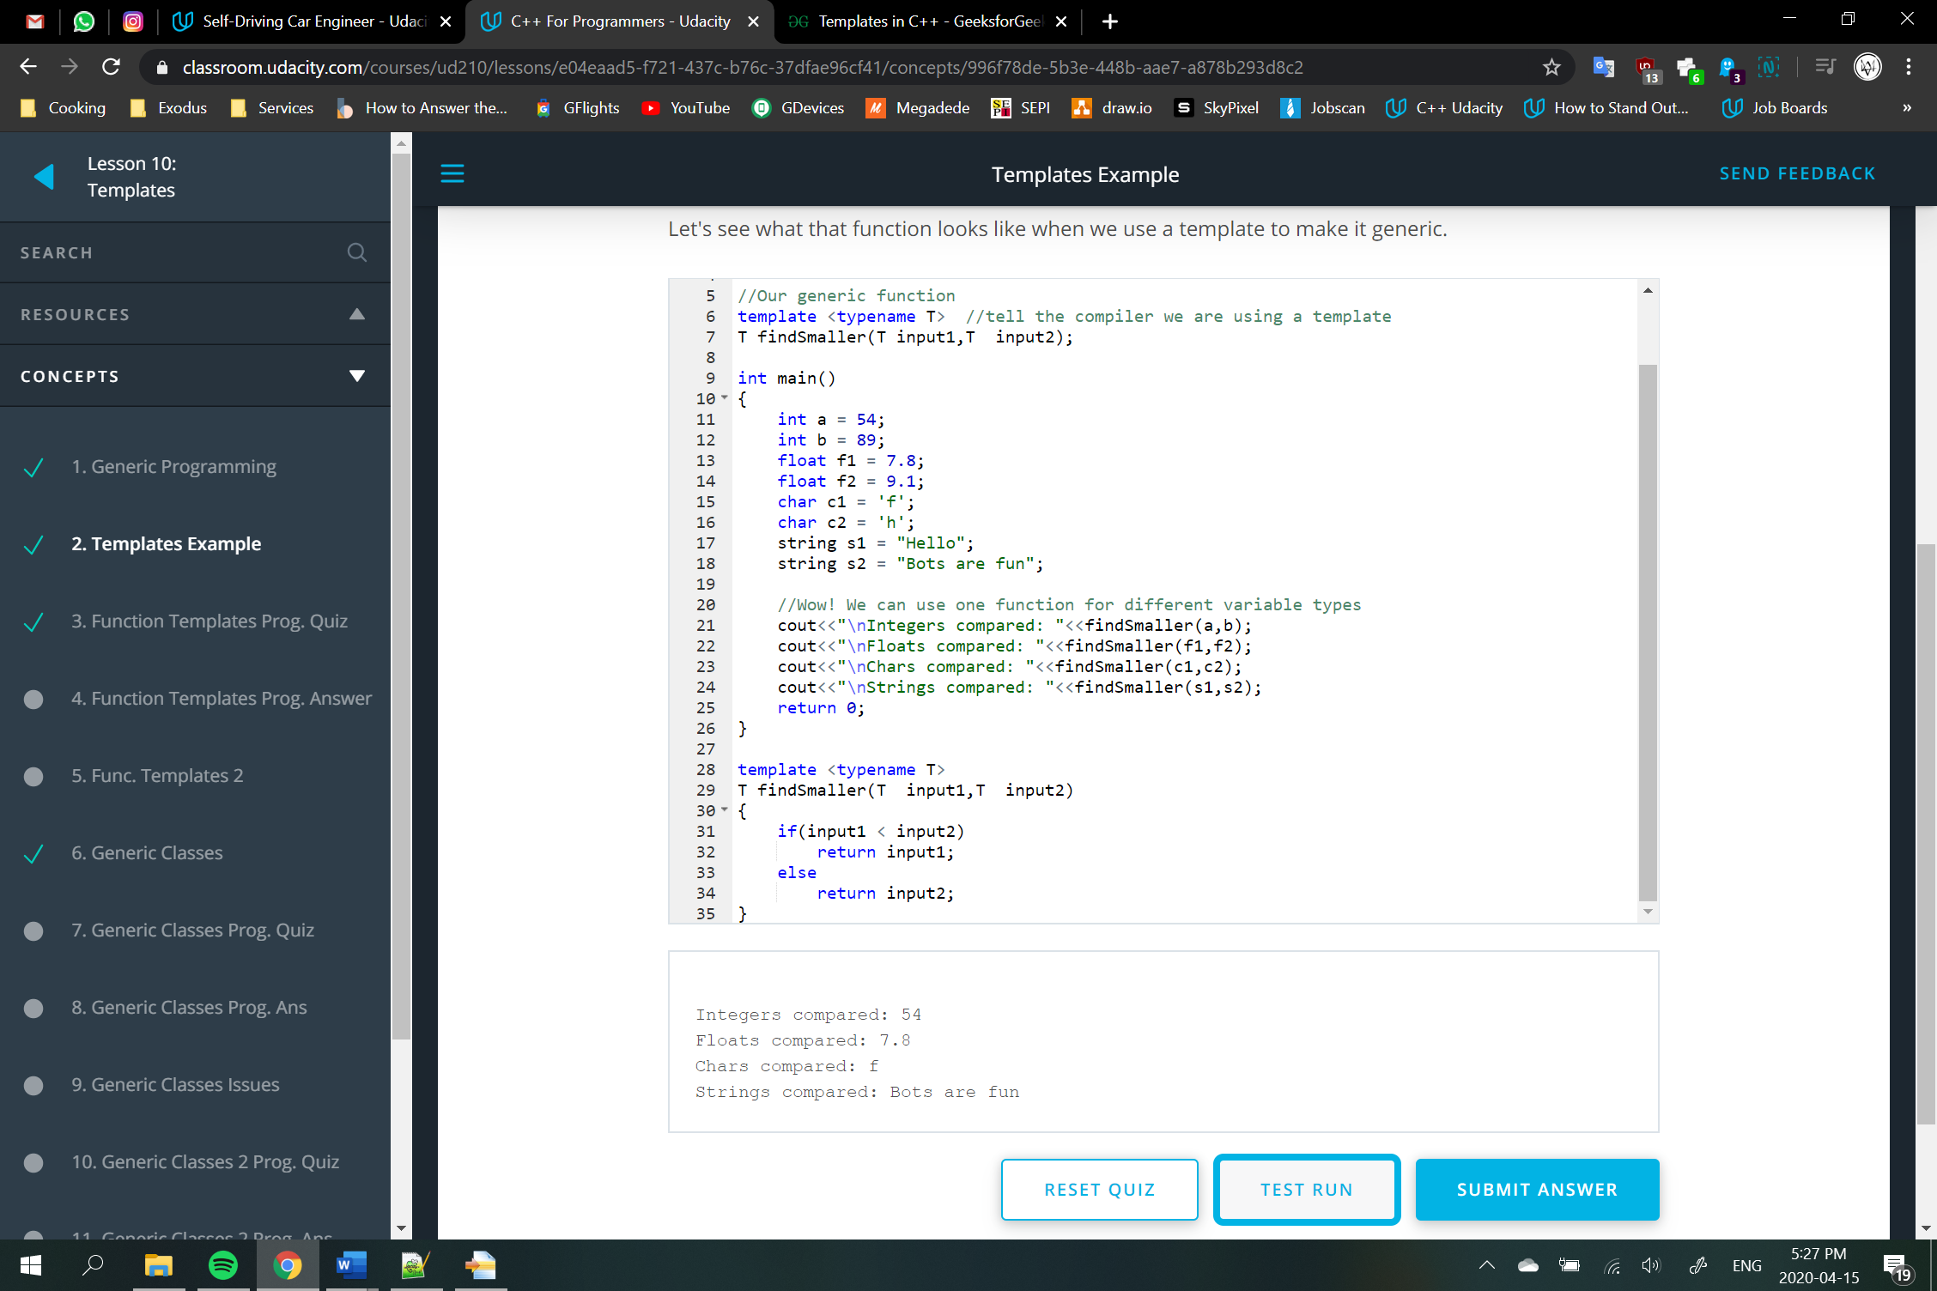

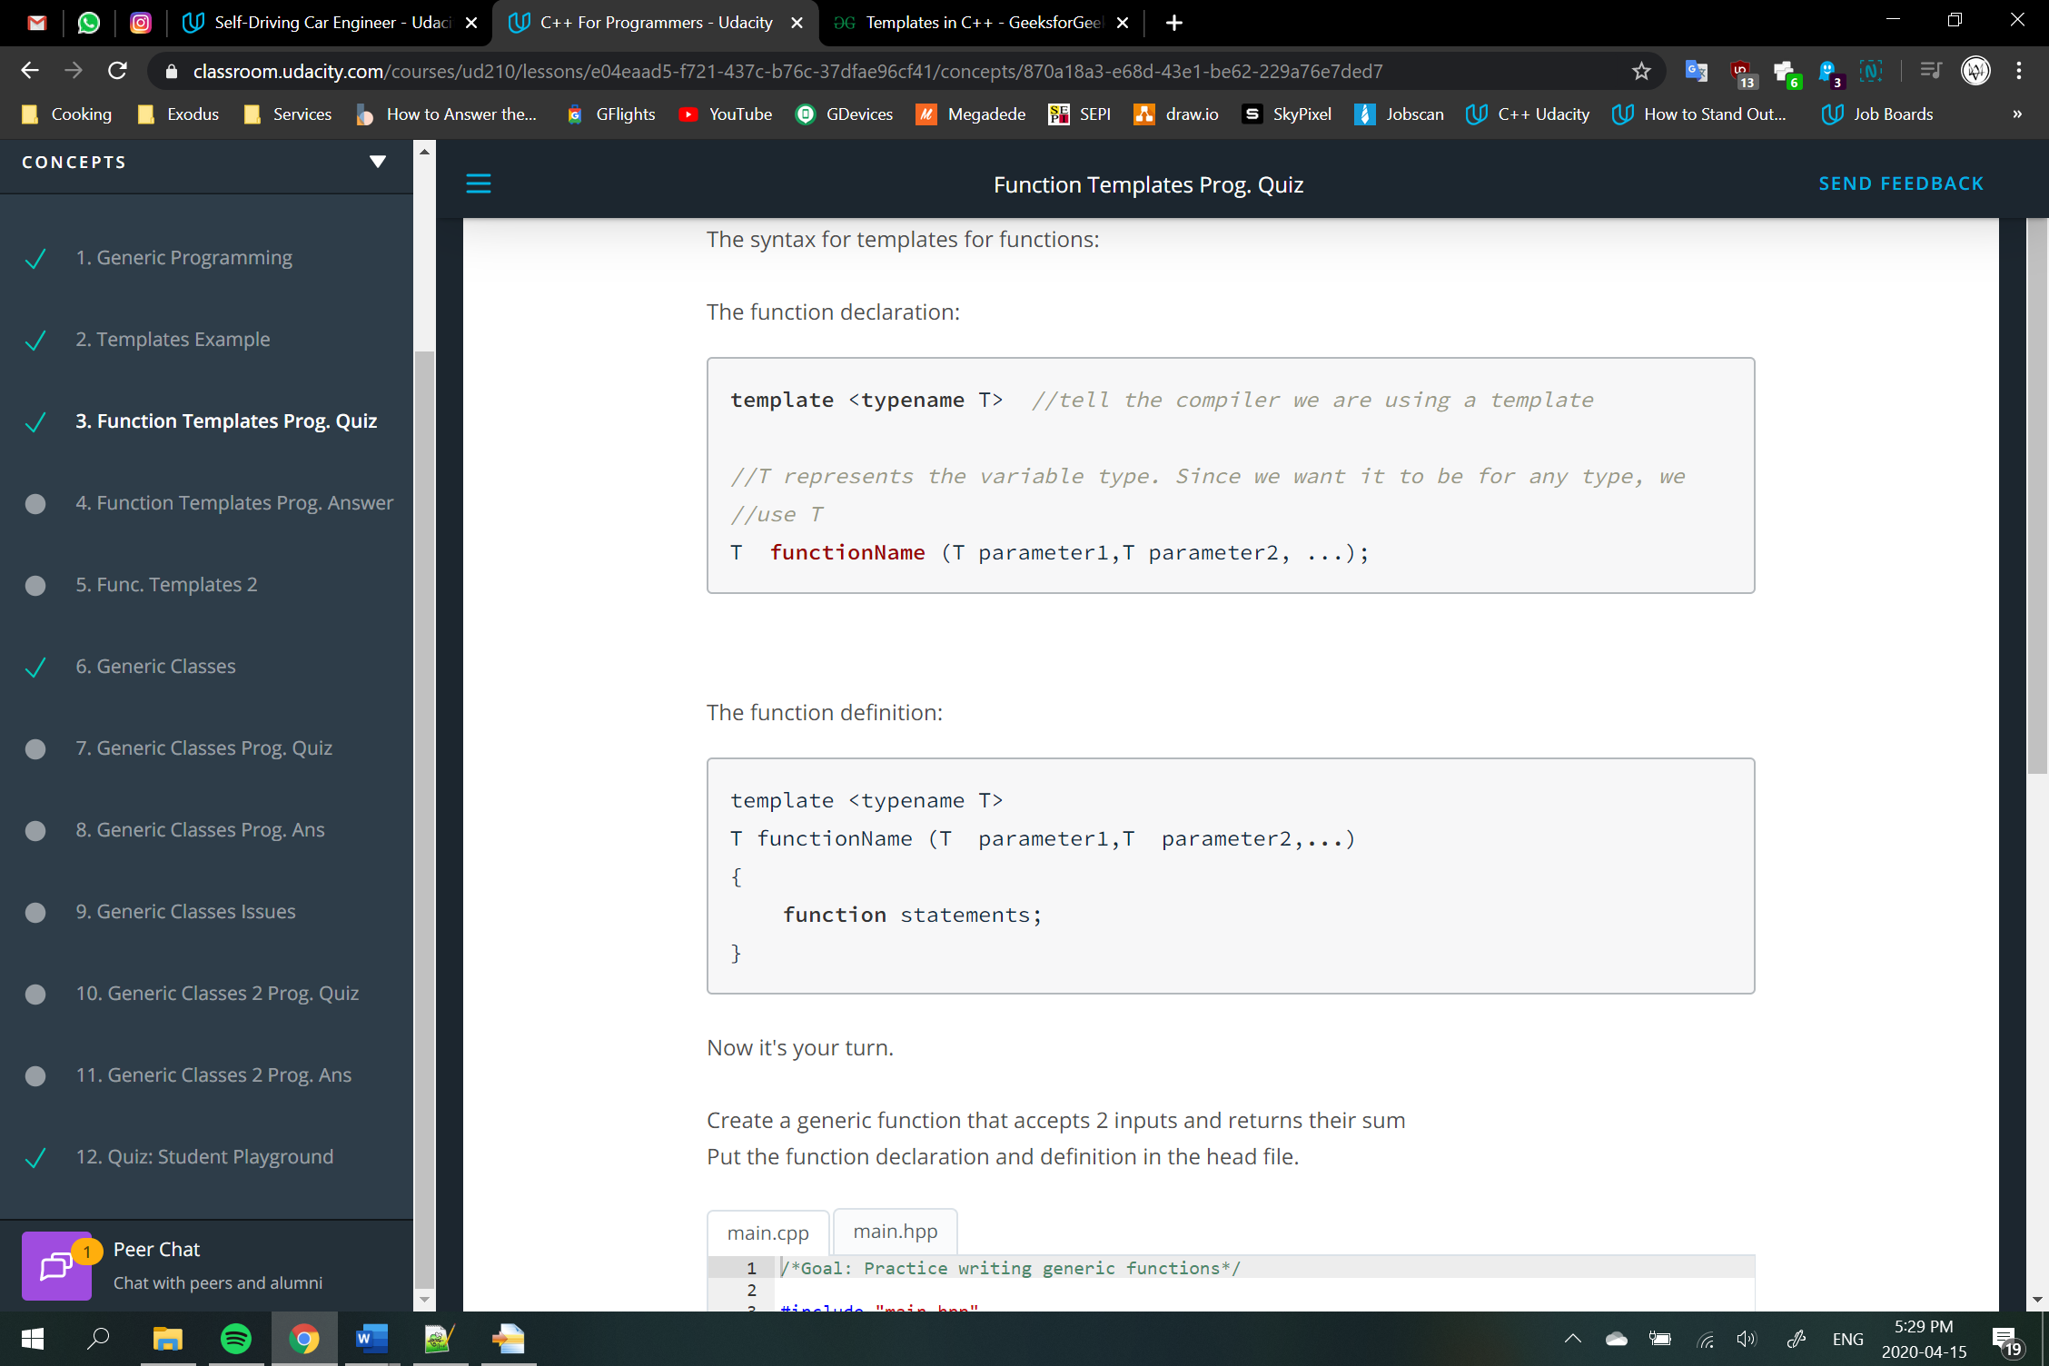

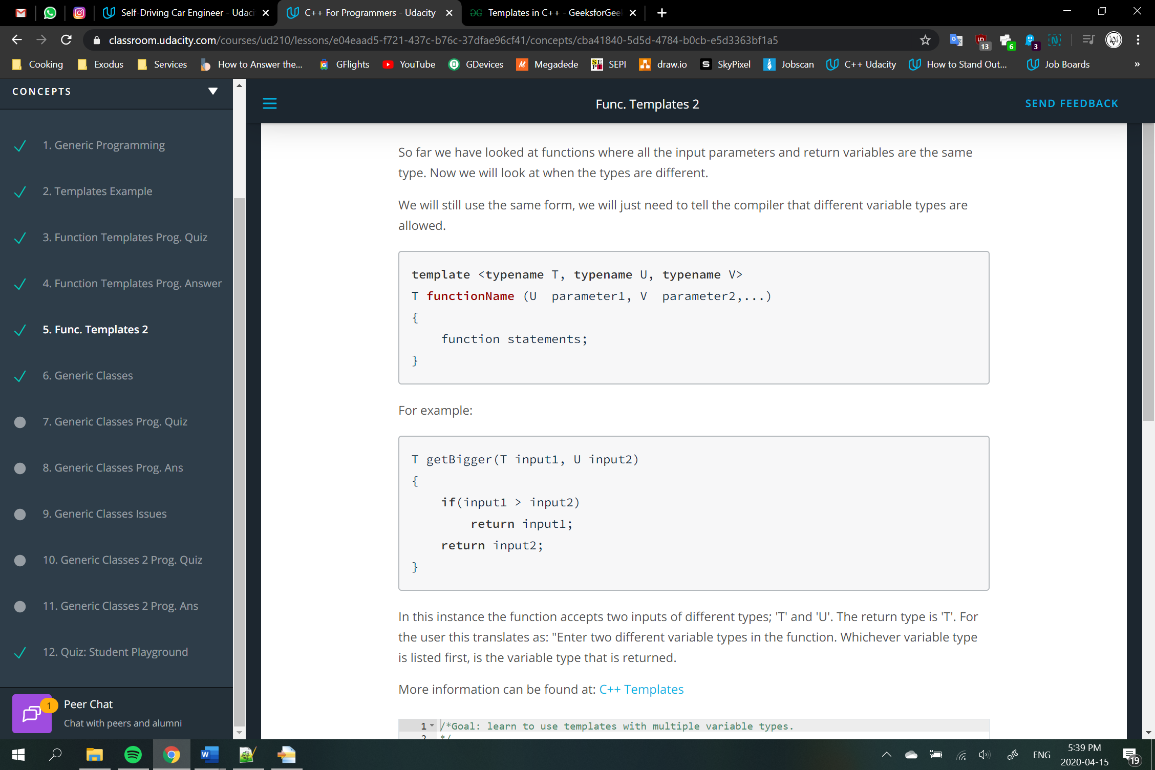

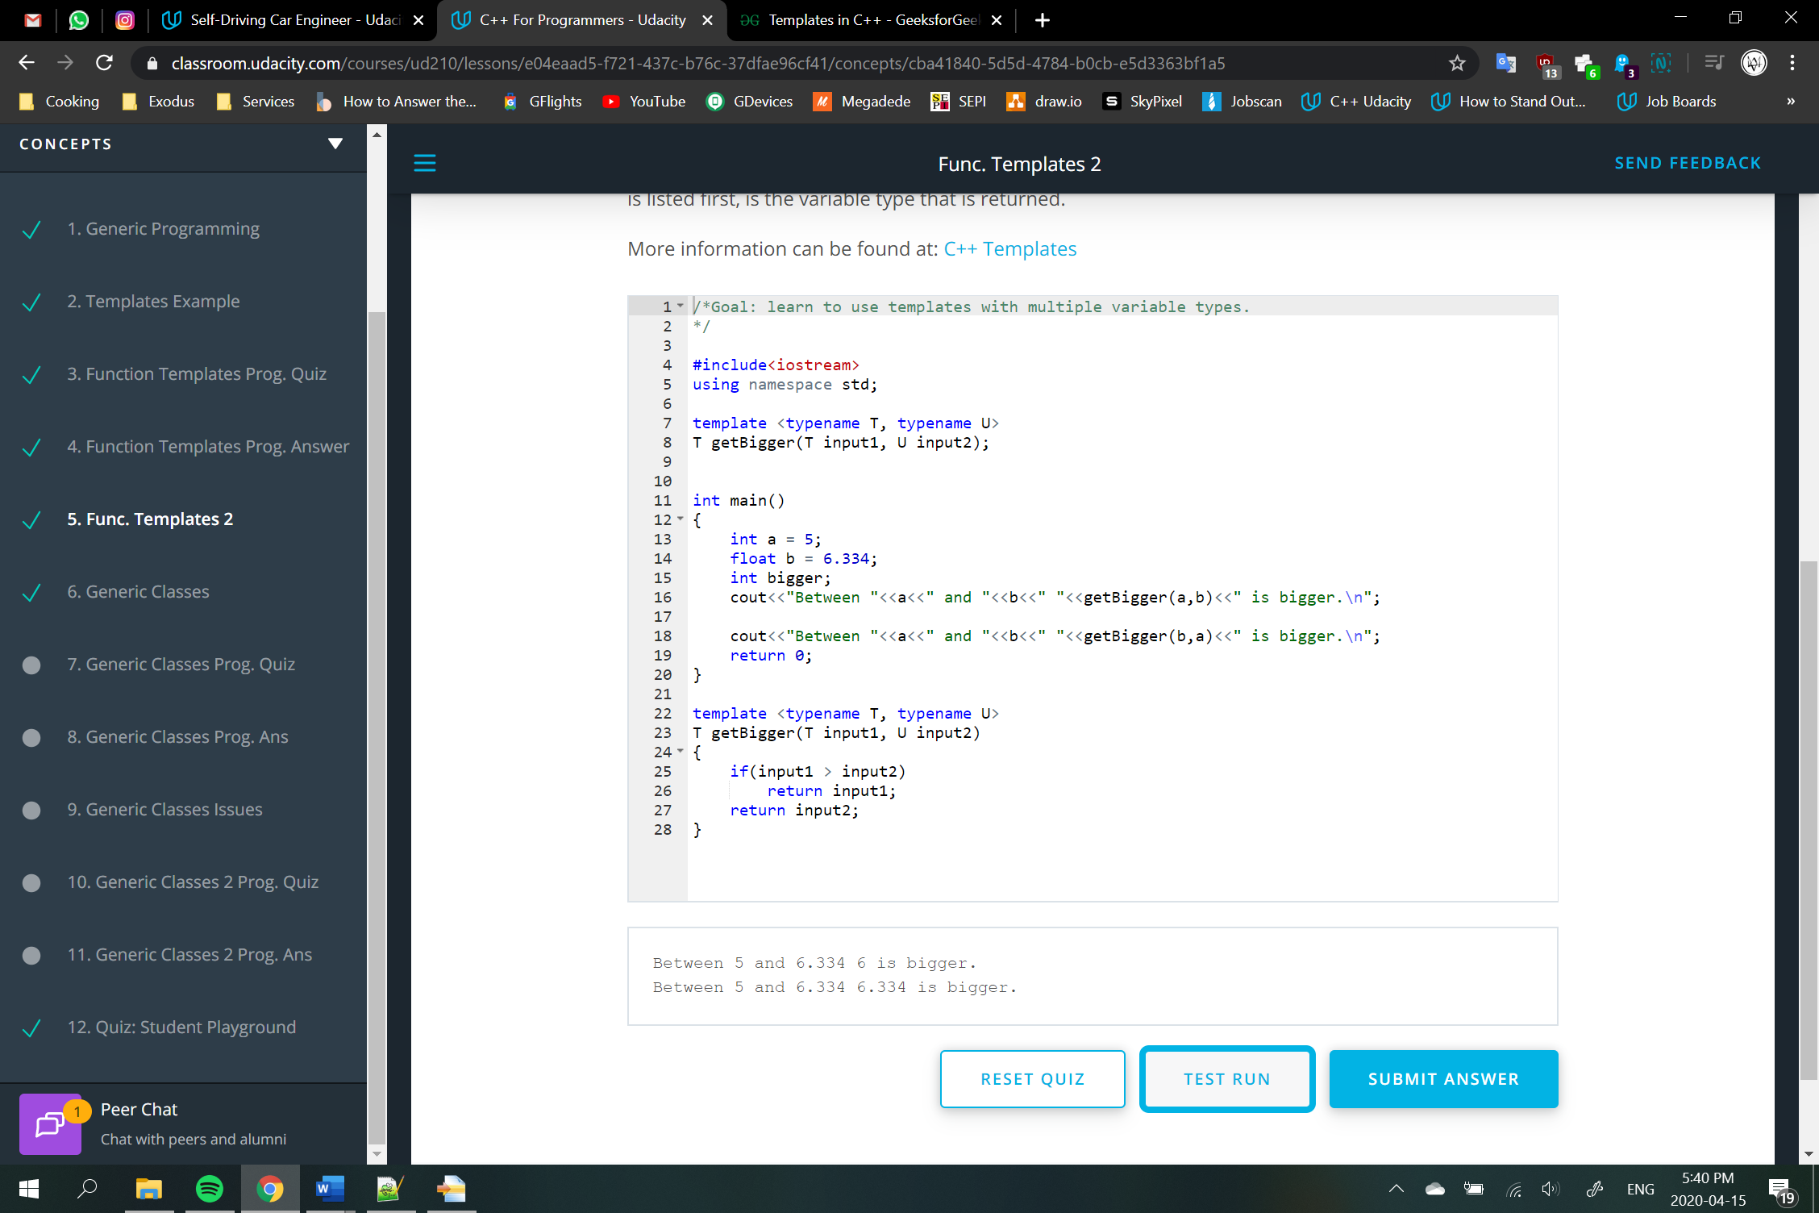

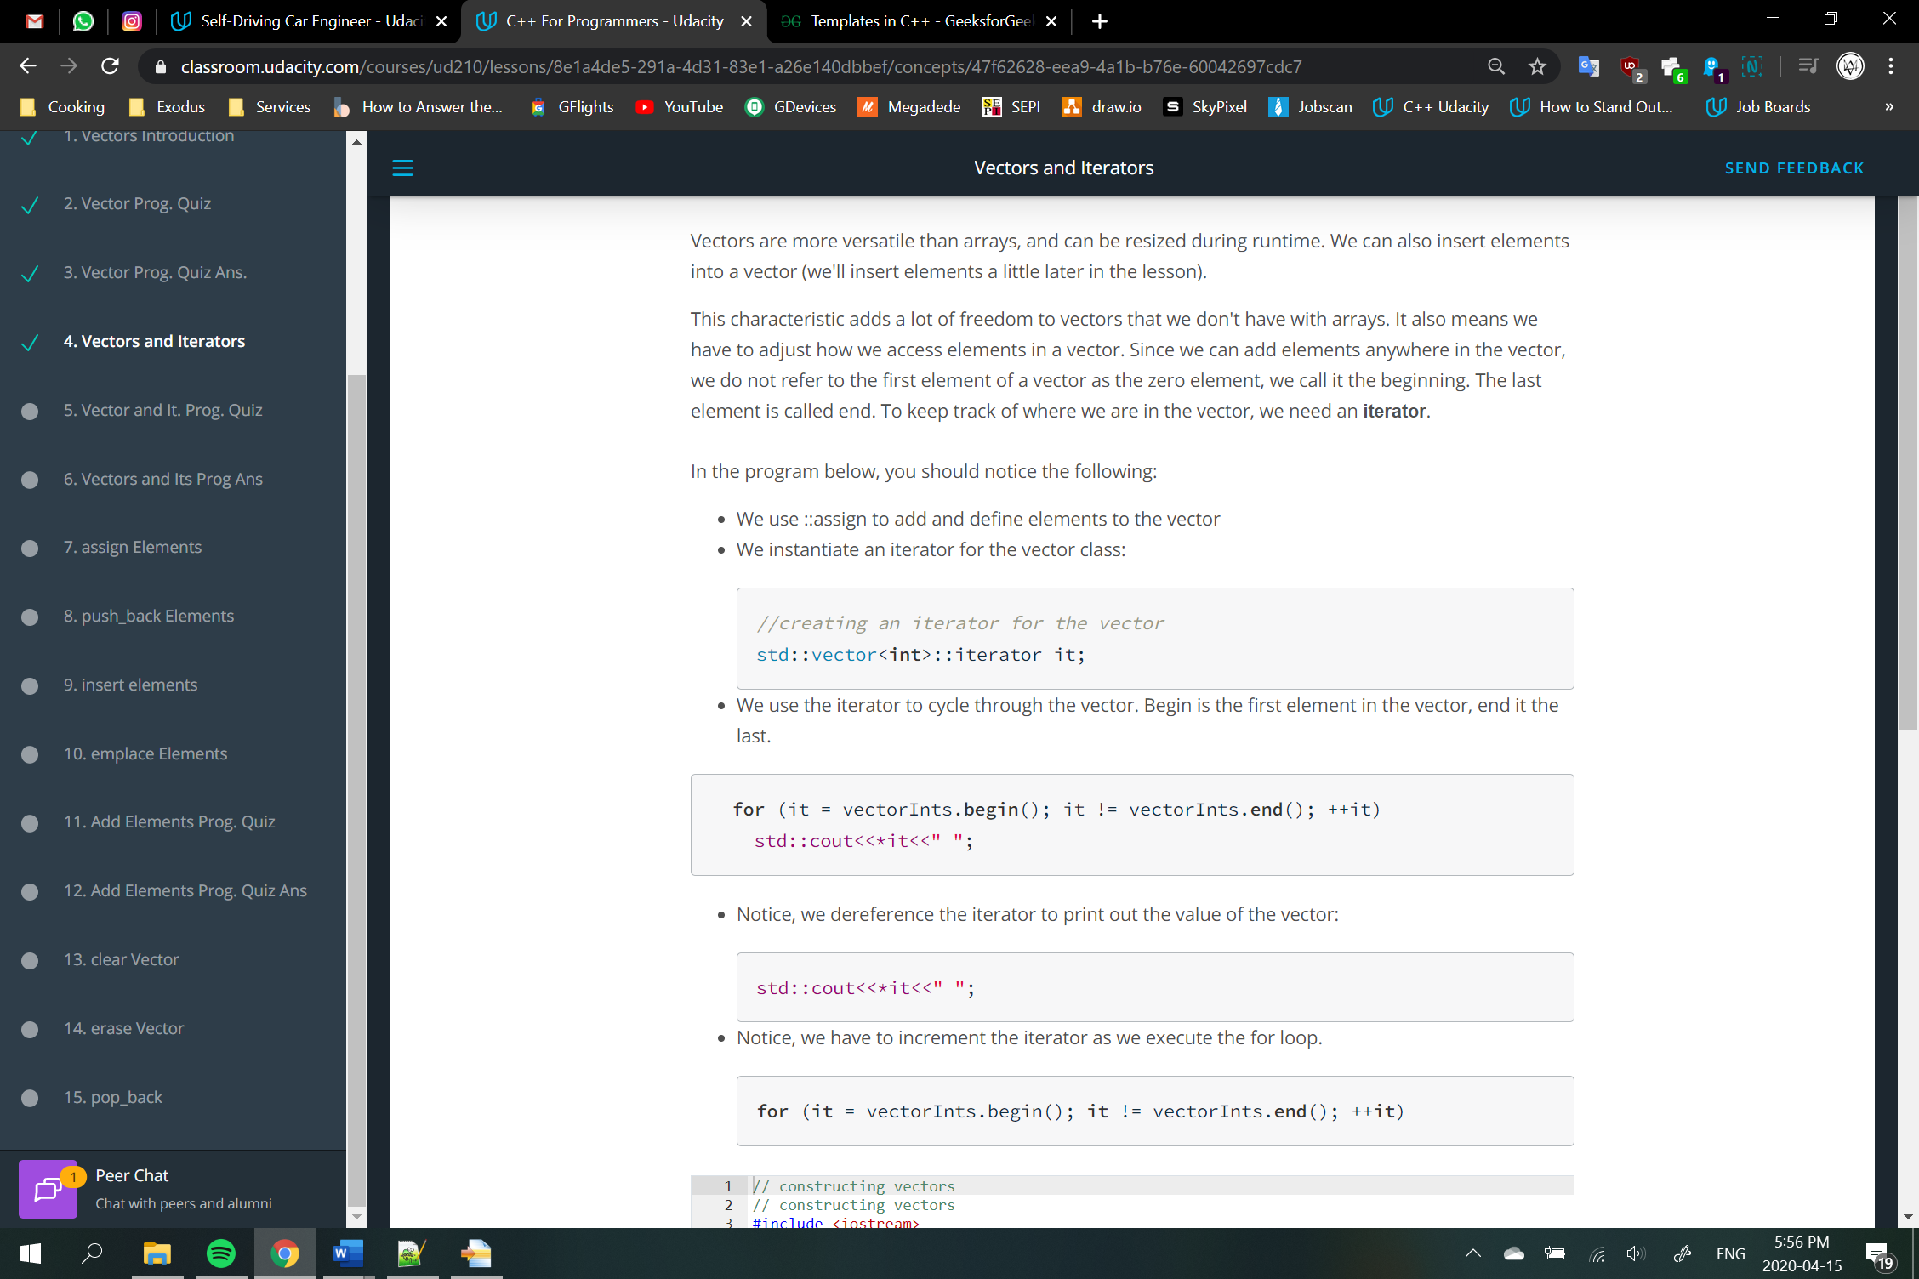

vectorA.assign(n, m) 🡪 assigns n times, m value

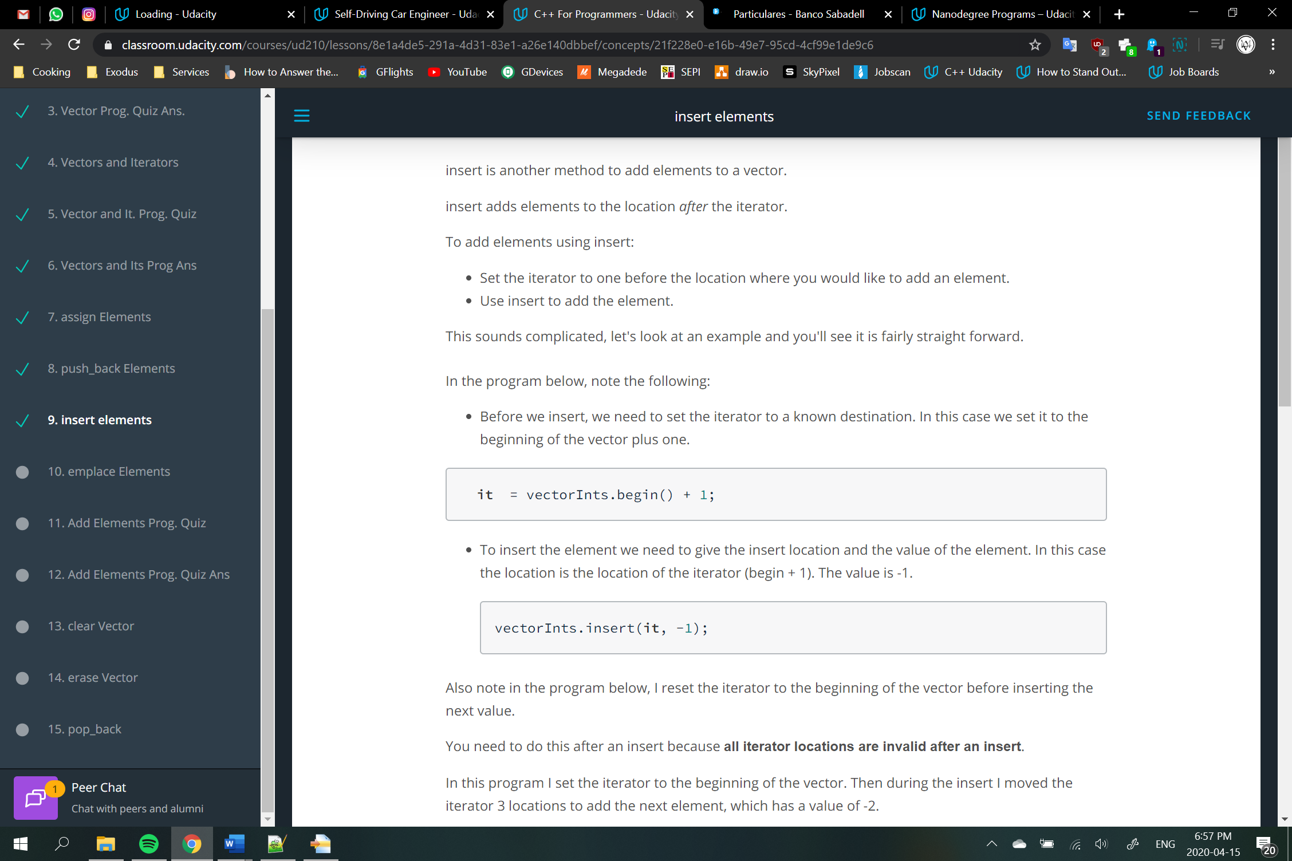

The advantage of emplace is, it does in-place insertion and avoids an unnecessary copy of object. For primitive data types, it does not matter which one we use. But for objects, use of emplace() is preferred for efficiency reasons.

